***************************************** **Up work-Casebook** *************************************************

**Freelancer section**

**Date: 09-06-2023**

1. [**http://localhost/upwork-casebook/en/dashboard/**](http://localhost/upwork-casebook/en/dashboard/) **(Image not display in Dashboard )**

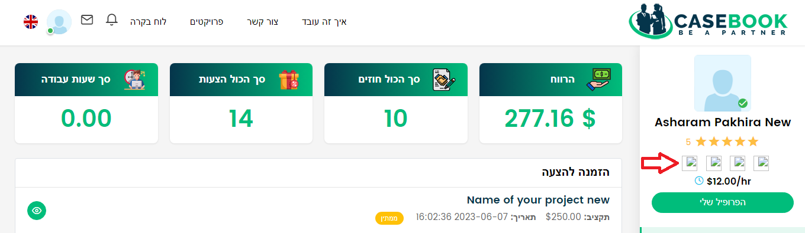

1. [**http://localhost/upwork-casebook/notification**](http://localhost/upwork-casebook/notification) **(Notification is not display at Hebrew language)**

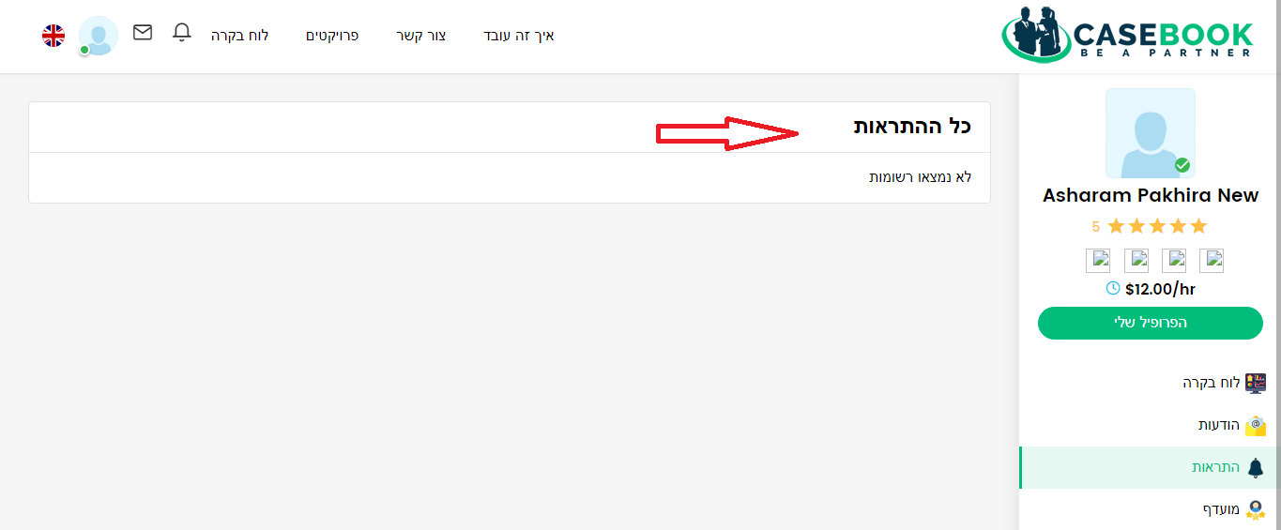

1. [**http://localhost/upwork-casebook/reviews**](http://localhost/upwork-casebook/reviews) **(At Review section Text should be right side)**

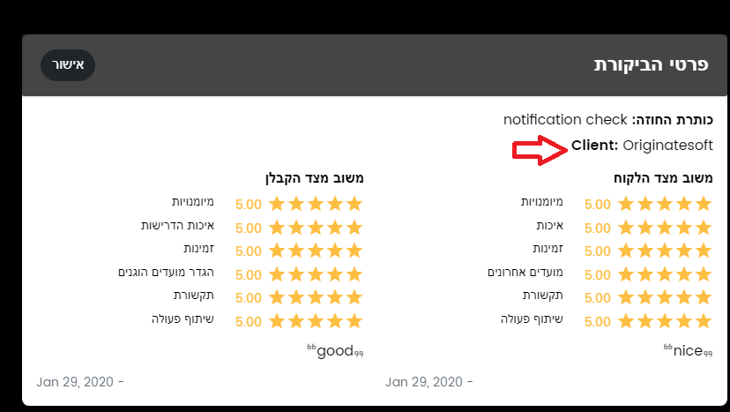

1. [**http://localhost/upwork-casebook/projectview/application/6/4**](http://localhost/upwork-casebook/projectview/application/6/4) **(At Hebrew language Page show an error)**

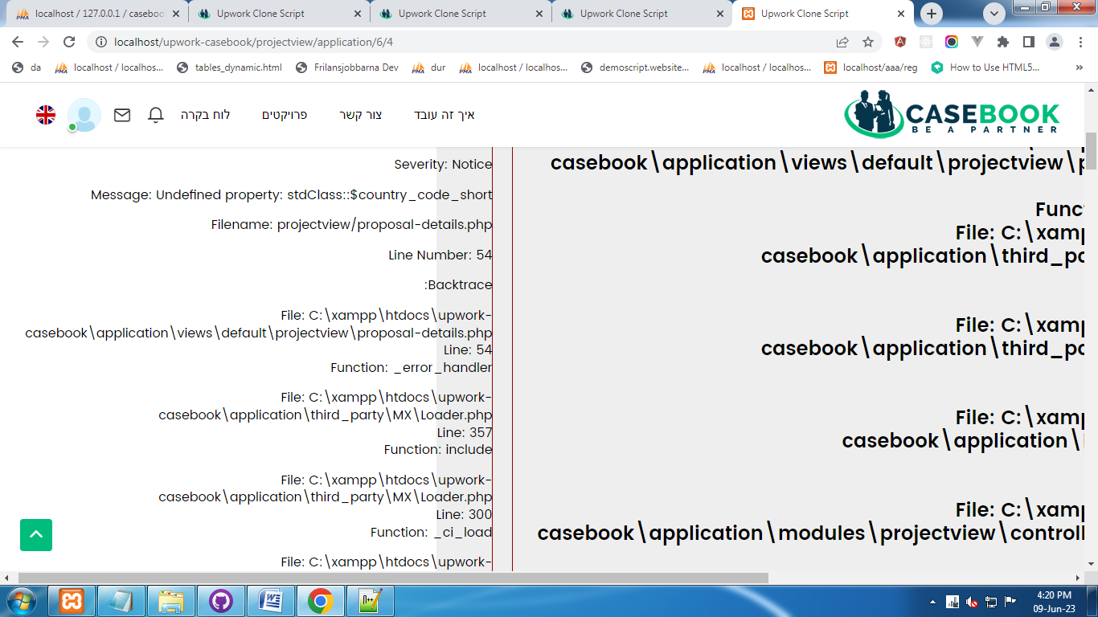

1. [**http://localhost/upwork-casebook/profileview/view/1**](http://localhost/upwork-casebook/profileview/view/1) **( Radio button is not proper place at Hebrew language)**

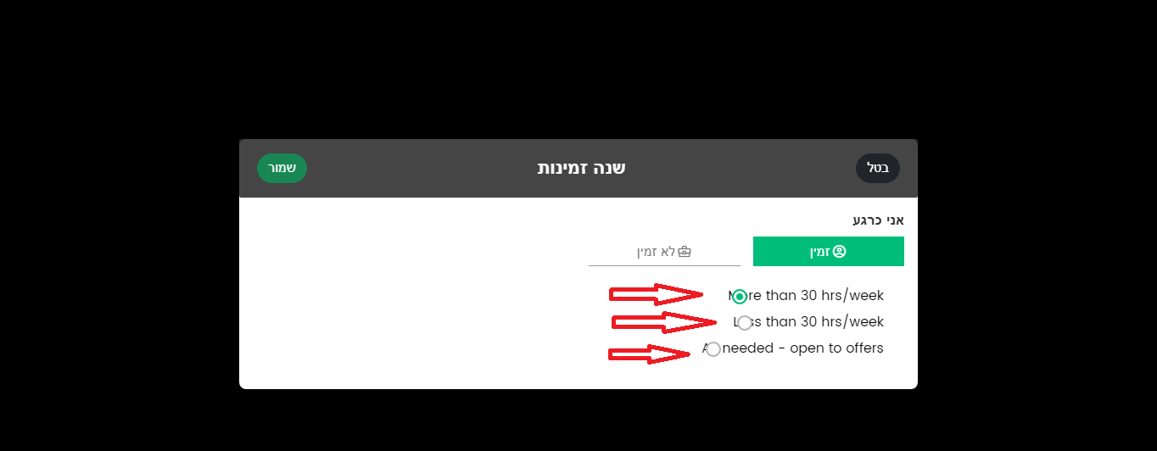

1. [**http://localhost/upwork-casebook/en/profileview/view/1**](http://localhost/upwork-casebook/en/profileview/view/1) **(My skills is not show at Hebrew Language)**

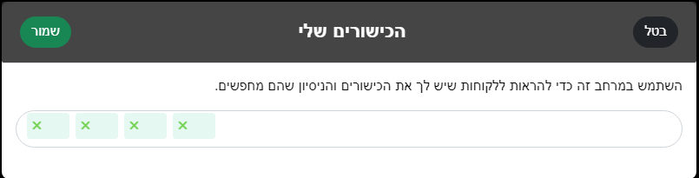

1. [**http://localhost/upwork-casebook/profileview/view/1**](http://localhost/upwork-casebook/profileview/view/1) **(At Hebrew language pop form is not open at the time of edit)**

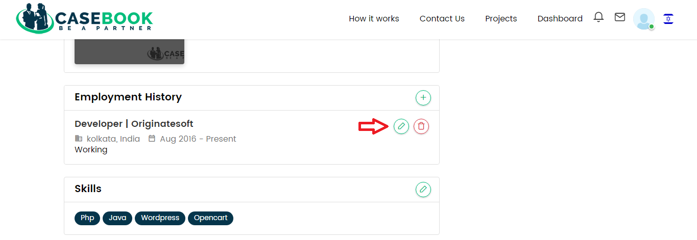

1. [**http://localhost/upwork-casebook/en/profileview/view/1**](http://localhost/upwork-casebook/en/profileview/view/1) **(At Hebrew language “Add” & “Edit” option is not work under “Employment History” section)**

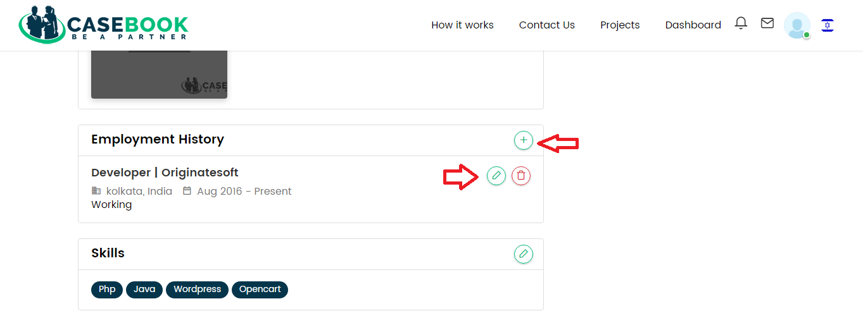

1. [**http://localhost/upwork-casebook/profileview/view/1**](http://localhost/upwork-casebook/profileview/view/1) **(At Hebrew language heading text should be right side)**

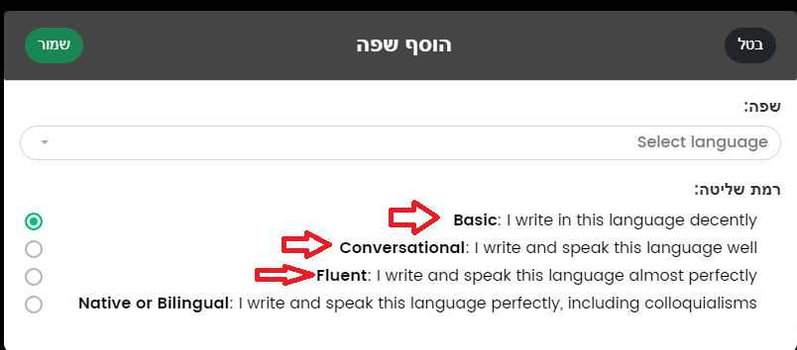

1. [**http://localhost/upwork-casebook/en/p/design-test**](http://localhost/upwork-casebook/en/p/design-test) **(At Hebrew language text is not display)**

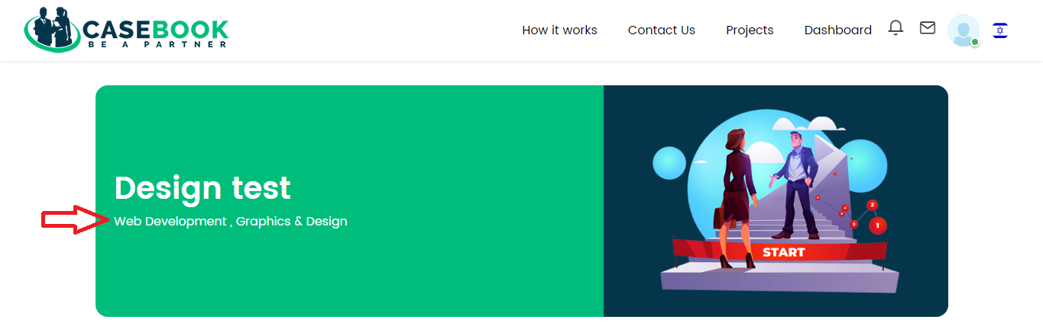

1. [**http://localhost/upwork-casebook/p/design-test**](http://localhost/upwork-casebook/p/design-test) **(At Hebrew language “OK” button should be left side)**

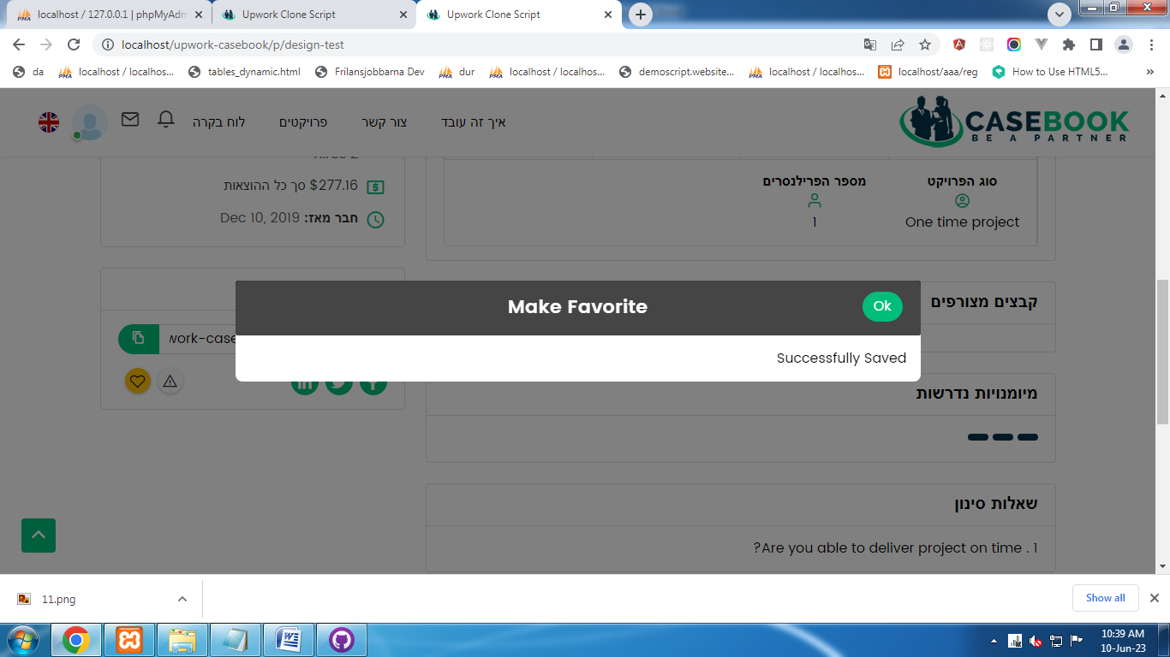

1. [**http://localhost/upwork-casebook/en/p/design-test**](http://localhost/upwork-casebook/en/p/design-test) **(At Hebrew language Skills required is not show)**

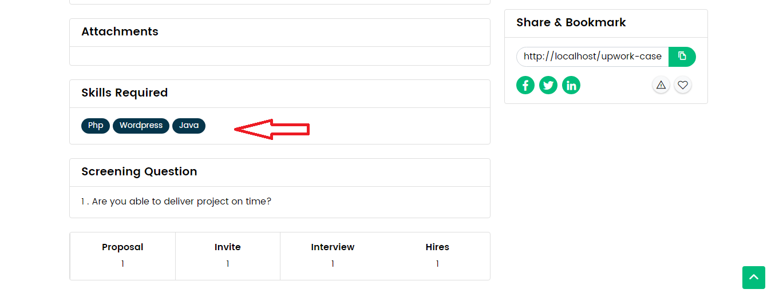

**Employer Section**

**Date: 10-06-2023**

1. [**http://localhost/upwork-casebook/en/p/name-of-your-project-6**](http://localhost/upwork-casebook/en/p/name-of-your-project-6) **(At Hebrew language location name is not show)**

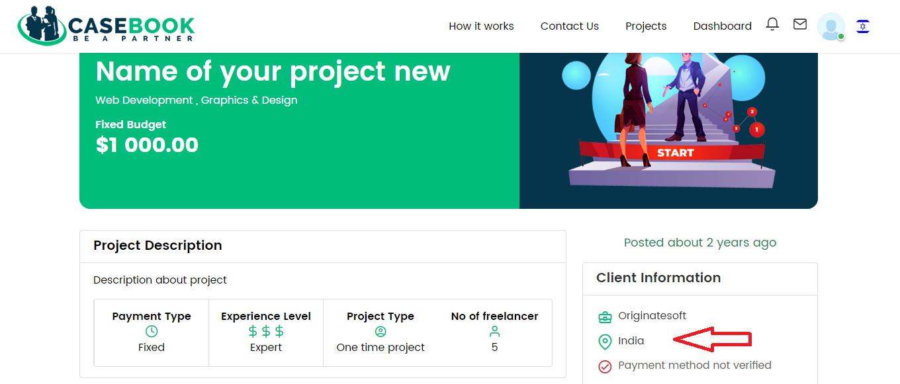

1. [**http://localhost/upwork-casebook/profileview/view/1**](http://localhost/upwork-casebook/profileview/view/1) **(At Hebrew language skills details not show)**

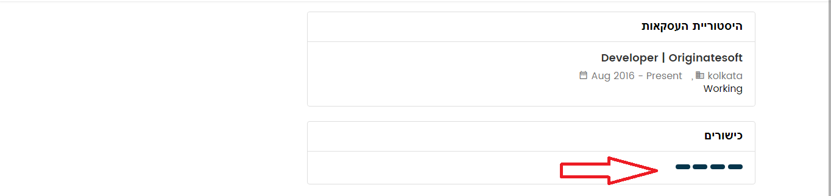

1. [**http://localhost/upwork-casebook/en/profileview/view/1**](http://localhost/upwork-casebook/en/profileview/view/1) **(Image not properly display)**

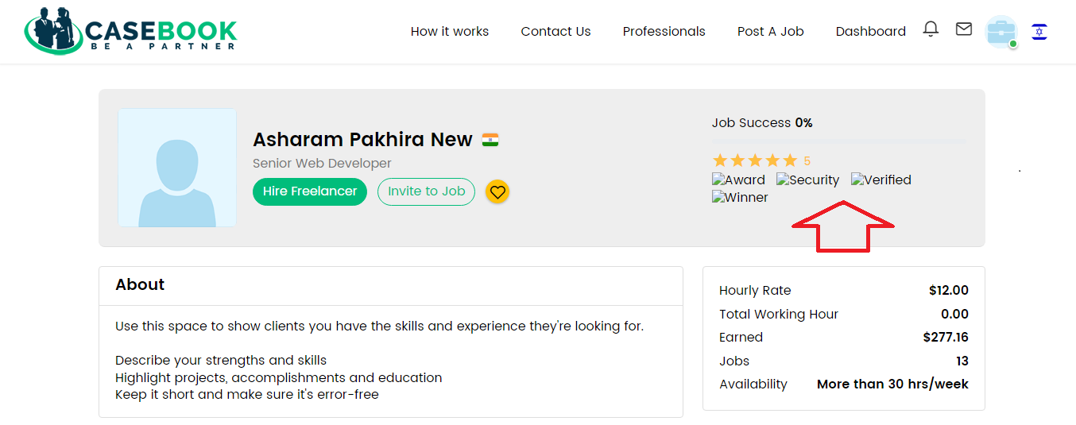

1. [**http://localhost/upwork-casebook/en/projectview/hire/8f14e45fceea167a5a36dedd4bea2543/9bf31c7ff062936a96d3c8bd1f8f2ff3**](http://localhost/upwork-casebook/en/projectview/hire/8f14e45fceea167a5a36dedd4bea2543/9bf31c7ff062936a96d3c8bd1f8f2ff3) **(At Hebrew language click on radio button design is not show properly)**

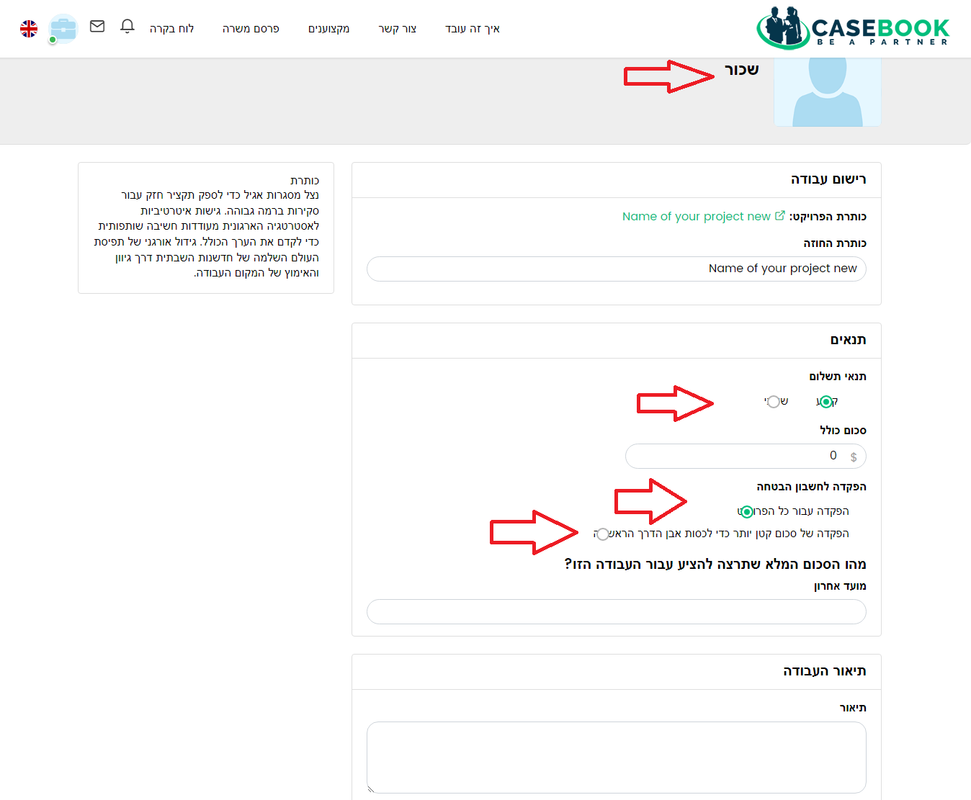

1. [**http://localhost/upwork-casebook/en/contract/details/aab3238922bcc25a6f606eb525ffdc56**](http://localhost/upwork-casebook/en/contract/details/aab3238922bcc25a6f606eb525ffdc56) **(At Hebrew language when click on “Close Project ” Button, then the pop up form become same as English language)**

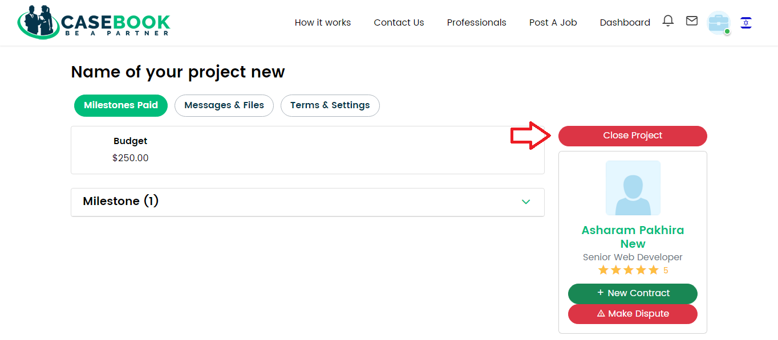

1. [**http://localhost/upwork-casebook/en/projectview/application/7/6**](http://localhost/upwork-casebook/en/projectview/application/7/6) **(At Hebrew language name details is not show)**

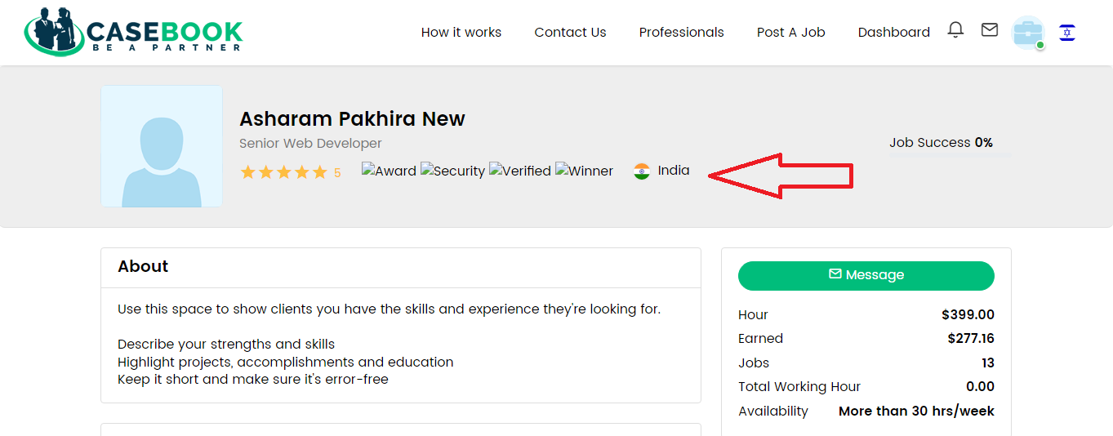

1. [**http://localhost/upwork-casebook/en/projectview/application/7/6**](http://localhost/upwork-casebook/en/projectview/application/7/6) **(preview option is not work with both languages)**

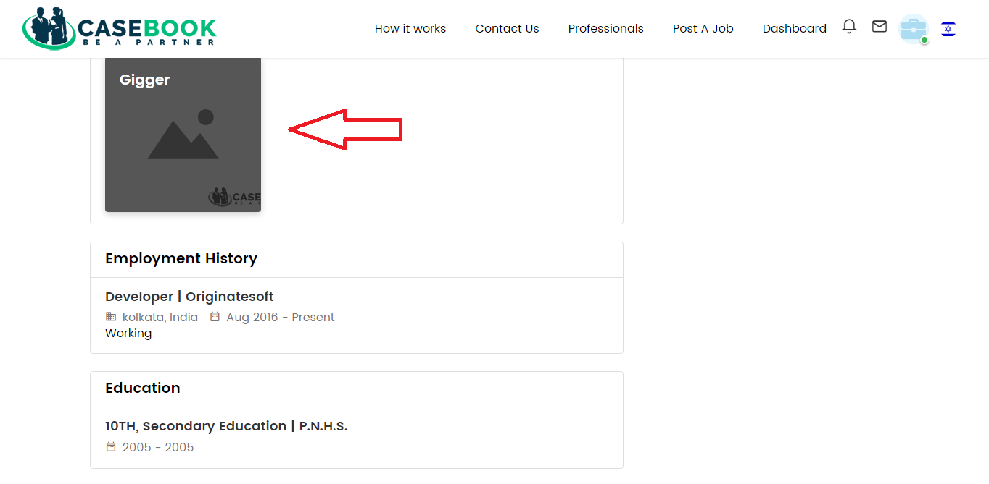

**Front Page in Website**

1. [**http://localhost/upwork-casebook/en/job/findjobs?order_by=default&category=&sub_category=&is_hourly=&experience_level=&job_type=&min=&max=&term**](http://localhost/upwork-casebook/en/job/findjobs?order_by=default&category=&sub_category=&is_hourly=&experience_level=&job_type=&min=&max=&term)**= (At Hebrew language Key skills is not show in each post)**

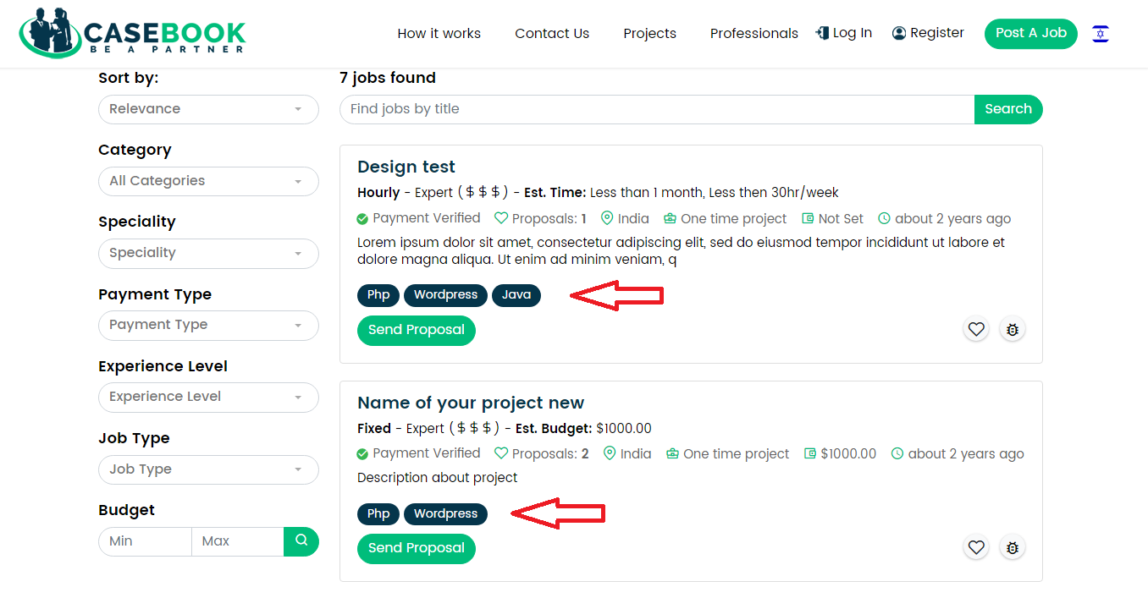

1. [**http://localhost/upwork-casebook/en/job/findjobs?order_by=default&category=&sub_category=&is_hourly=&experience_level=&job_type=&min=&max=&term**](http://localhost/upwork-casebook/en/job/findjobs?order_by=default&category=&sub_category=&is_hourly=&experience_level=&job_type=&min=&max=&term)**= (At Hebrew language “Cancel” and “Ok” button position is not changed )**

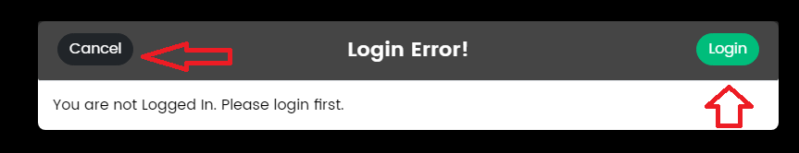

1. [**http://localhost/upwork-casebook/how-it-works**](http://localhost/upwork-casebook/how-it-works) **(At Hebrew language “How it Works ” page is not properly display)**

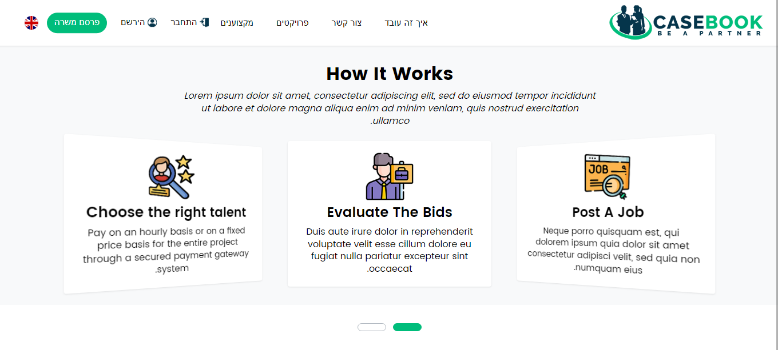

1. [**http://localhost/upwork-casebook/en/help**](http://localhost/upwork-casebook/en/help) **(At Hebrew Language Help section panel is not show)**

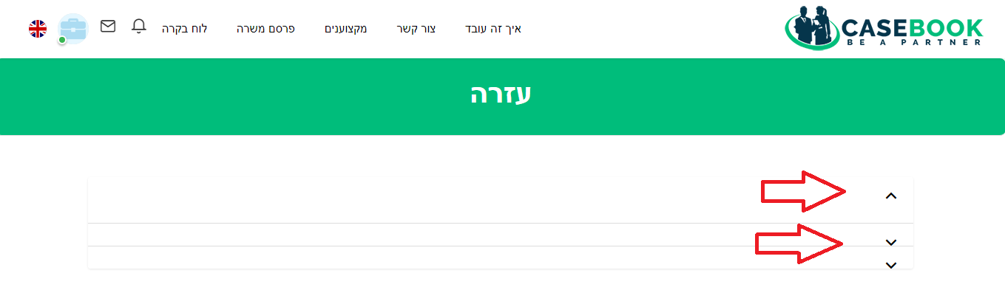

**24)** [**http://localhost/upwork-casebook/terms-and-conditions**](http://localhost/upwork-casebook/terms-and-conditions) **(Hebrew Language “Terms & Condition” title is not show)**

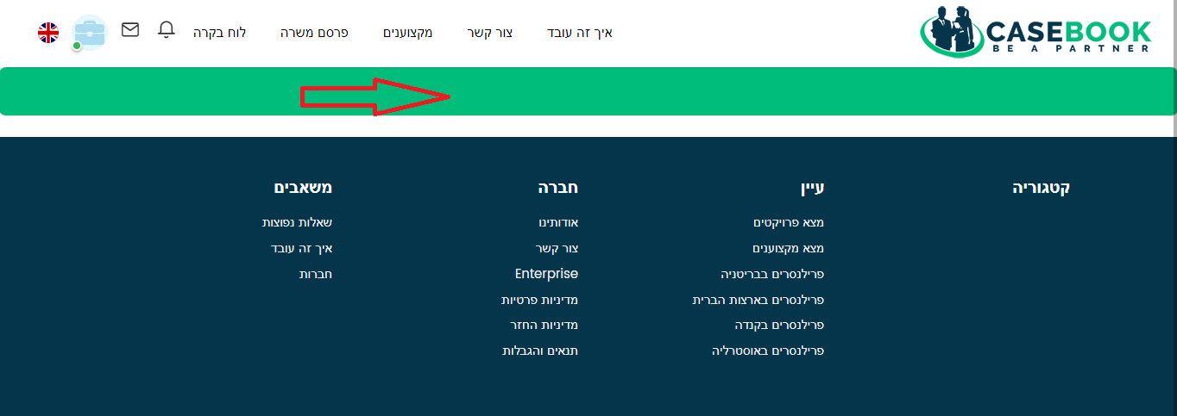

**25)** [**http://localhost/upwork-casebook/en/findtalents/all_list?country=AUS&min=&max=&min=&max=&term=&order_by=default**](http://localhost/upwork-casebook/en/findtalents/all_list?country=AUS&min=&max=&min=&max=&term=&order_by=default) **(Hebrew Language browse section is not show properly)**