***************************************** Up work-Casebook *************************************************
Freelancer section
Date: 09-06-2023
- http://localhost/upwork-casebook/en/dashboard/ (Image not display in Dashboard )
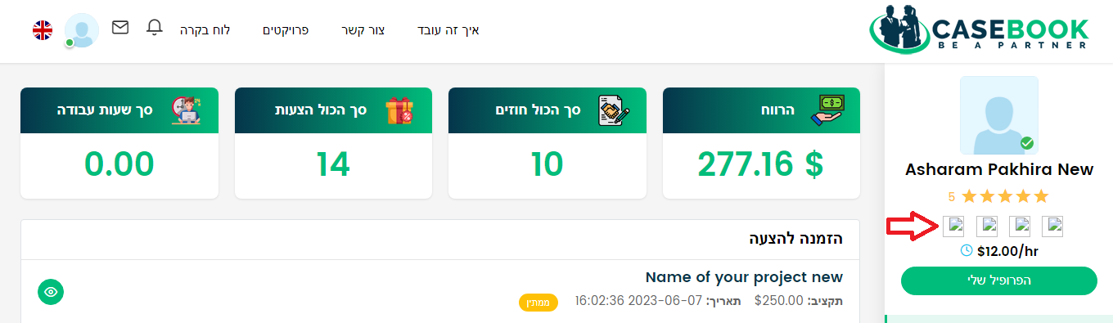

- http://localhost/upwork-casebook/notification (Notification is not display at Hebrew language)

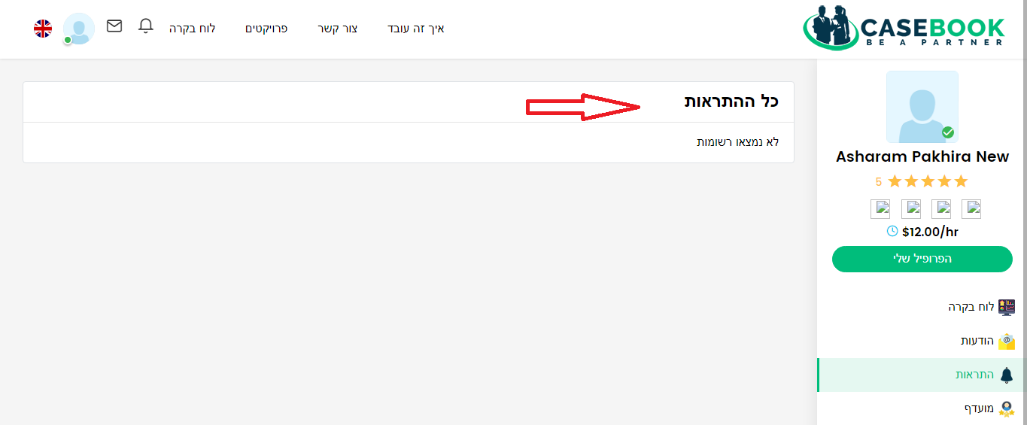

- http://localhost/upwork-casebook/reviews (At Review section Text should be right side)

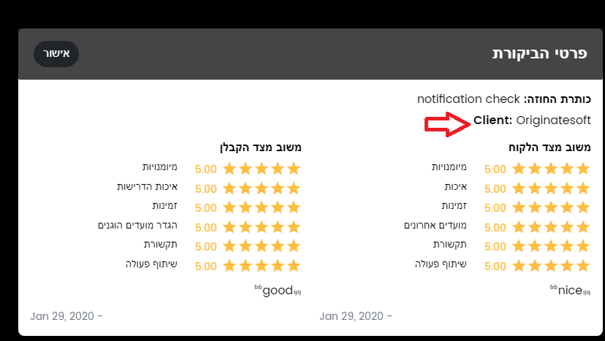

- http://localhost/upwork-casebook/projectview/application/6/4 (At Hebrew language Page show an error)

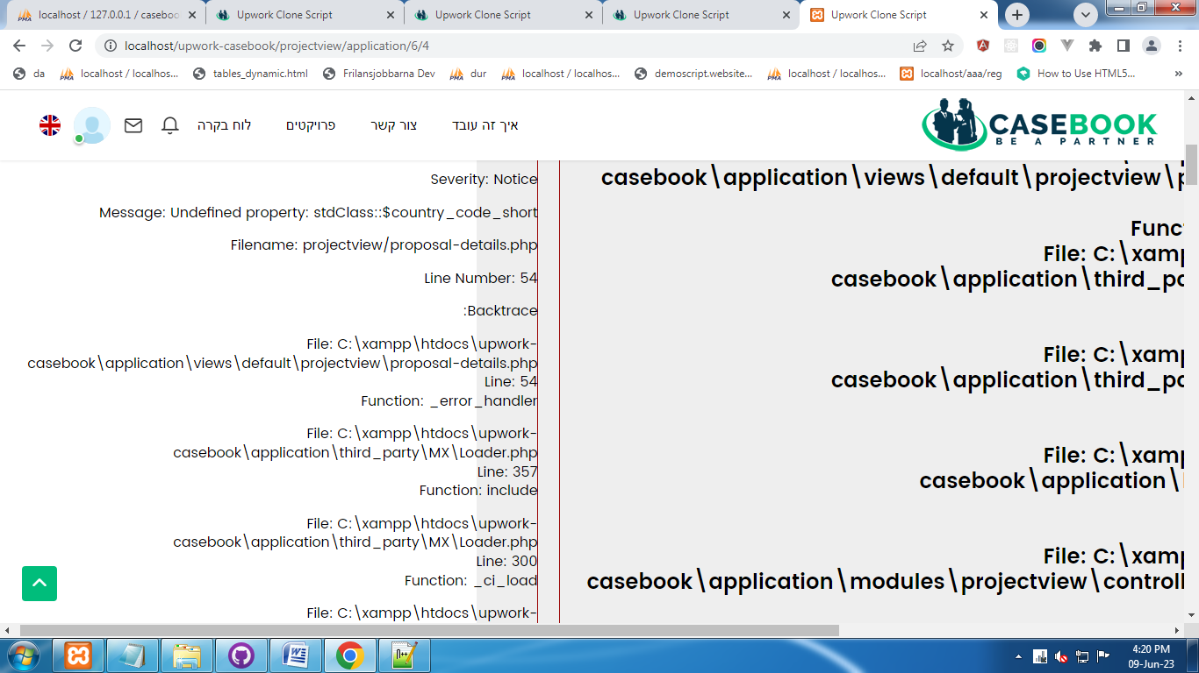

- http://localhost/upwork-casebook/profileview/view/1 ( Radio button is not proper place at Hebrew language)
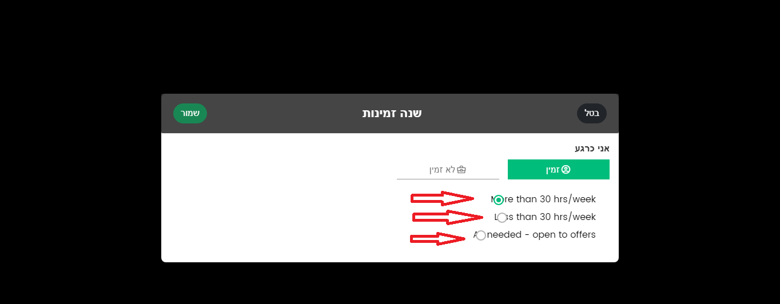

- http://localhost/upwork-casebook/en/profileview/view/1 (My skills is not show at Hebrew Language)

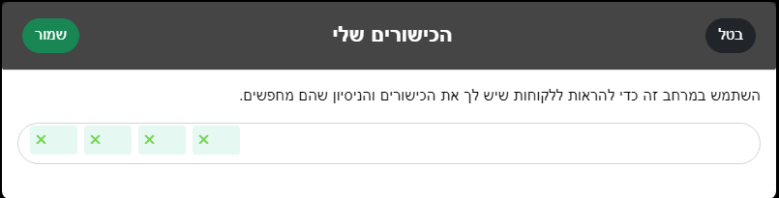

- http://localhost/upwork-casebook/profileview/view/1 (At Hebrew language pop form is not open at the time of edit)
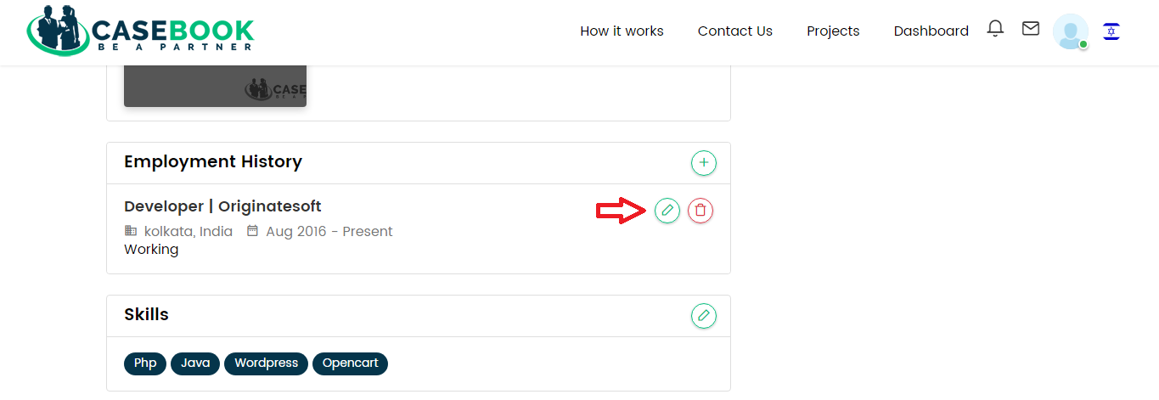

- http://localhost/upwork-casebook/en/profileview/view/1 (At Hebrew language “Add” & “Edit” option is not work under “Employment History” section)
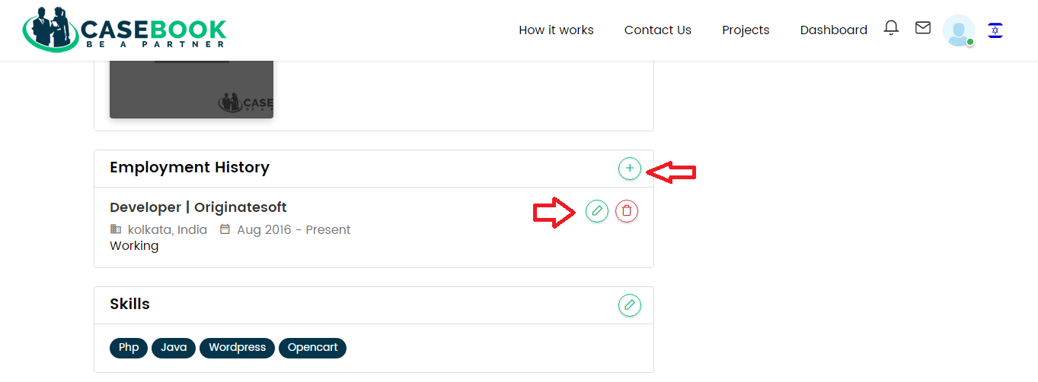

- http://localhost/upwork-casebook/profileview/view/1 (At Hebrew language heading text should be right side)

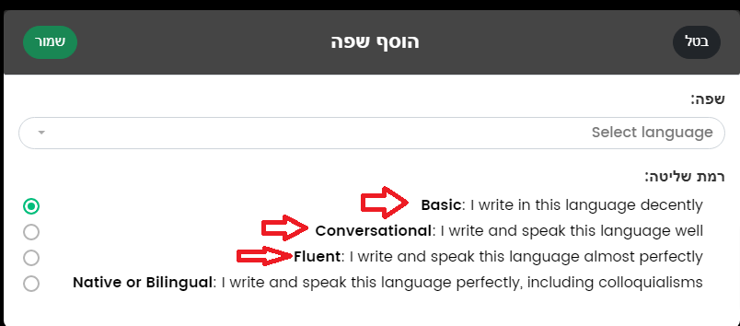

- http://localhost/upwork-casebook/en/p/design-test (At Hebrew language text is not display)

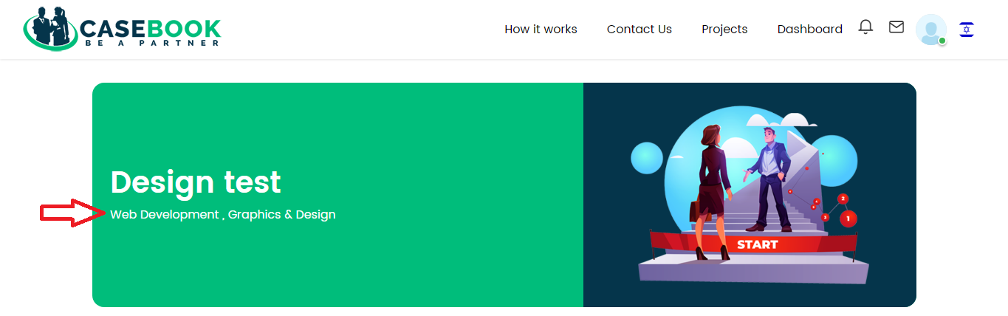

- http://localhost/upwork-casebook/p/design-test (At Hebrew language “OK” button should be left side)

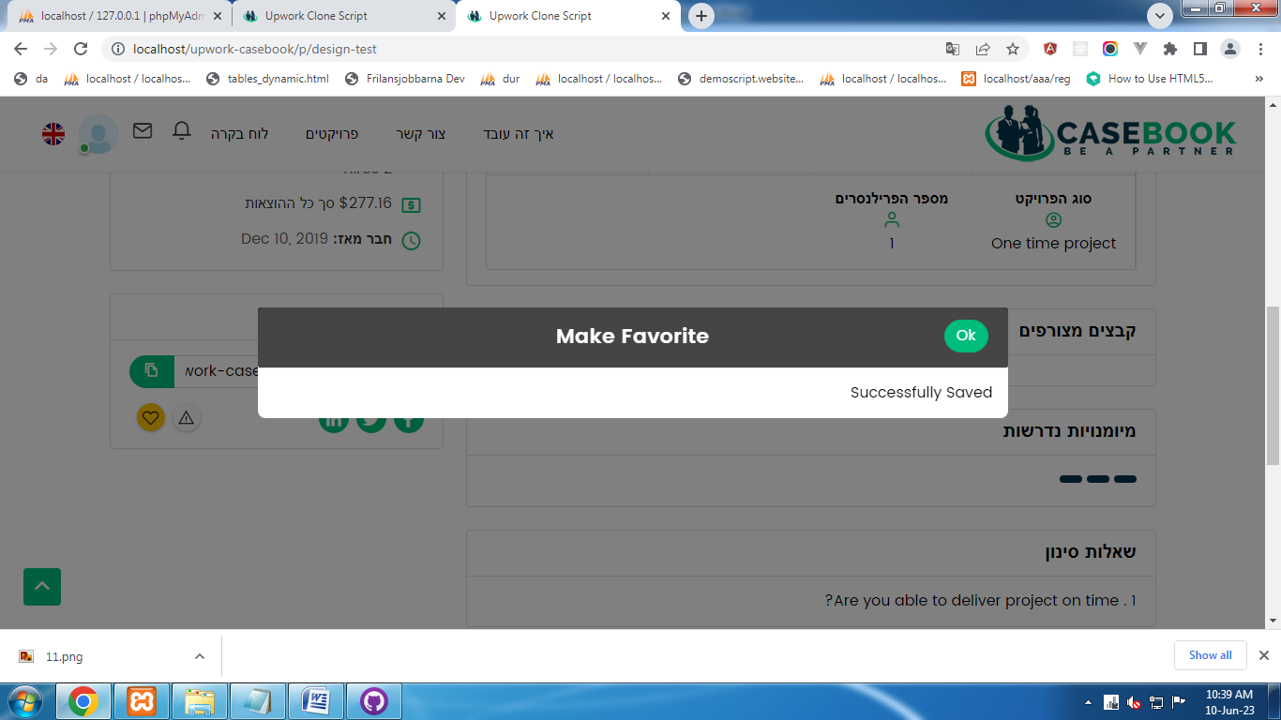

- http://localhost/upwork-casebook/en/p/design-test (At Hebrew language Skills required is not show)

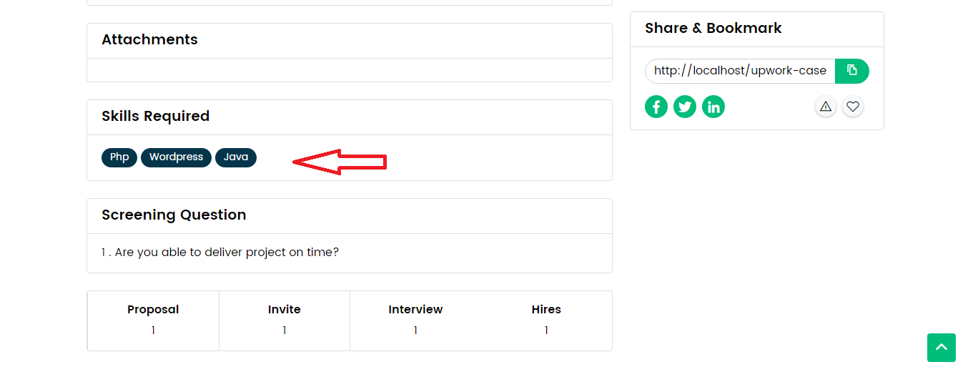

Employer Section
Date: 10-06-2023

- http://localhost/upwork-casebook/en/p/name-of-your-project-6 (At Hebrew language location name is not show)

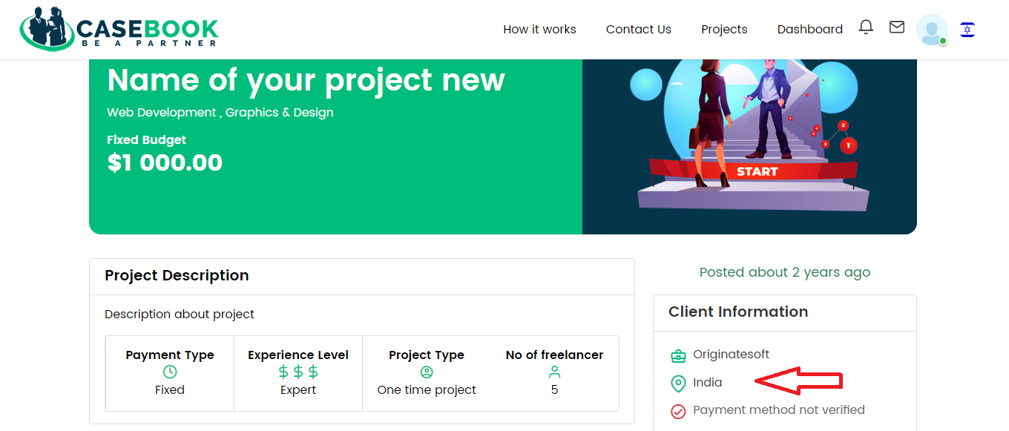

- http://localhost/upwork-casebook/profileview/view/1 (At Hebrew language skills details not show)
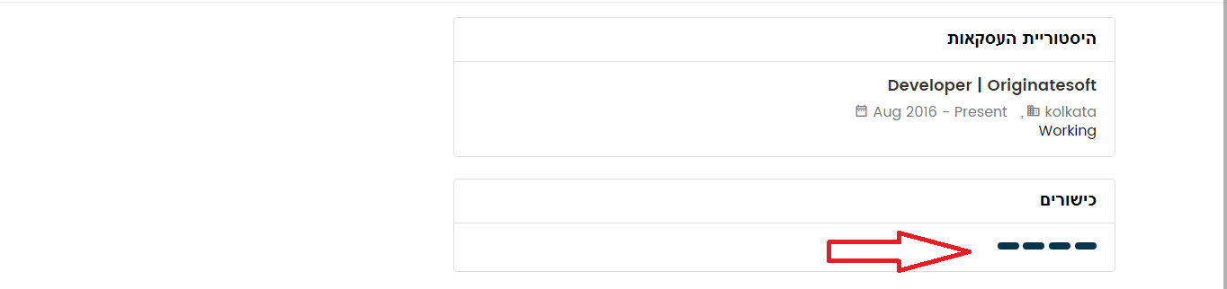

- http://localhost/upwork-casebook/en/profileview/view/1 (Image not properly display)

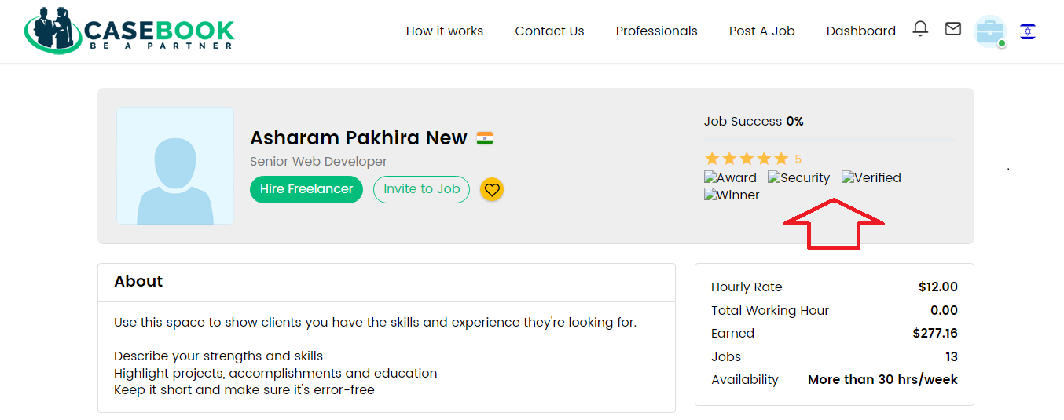

- http://localhost/upwork-casebook/en/projectview/hire/8f14e45fceea167a5a36dedd4bea2543/9bf31c7ff062936a96d3c8bd1f8f2ff3 (At Hebrew language click on radio button design is not show properly)
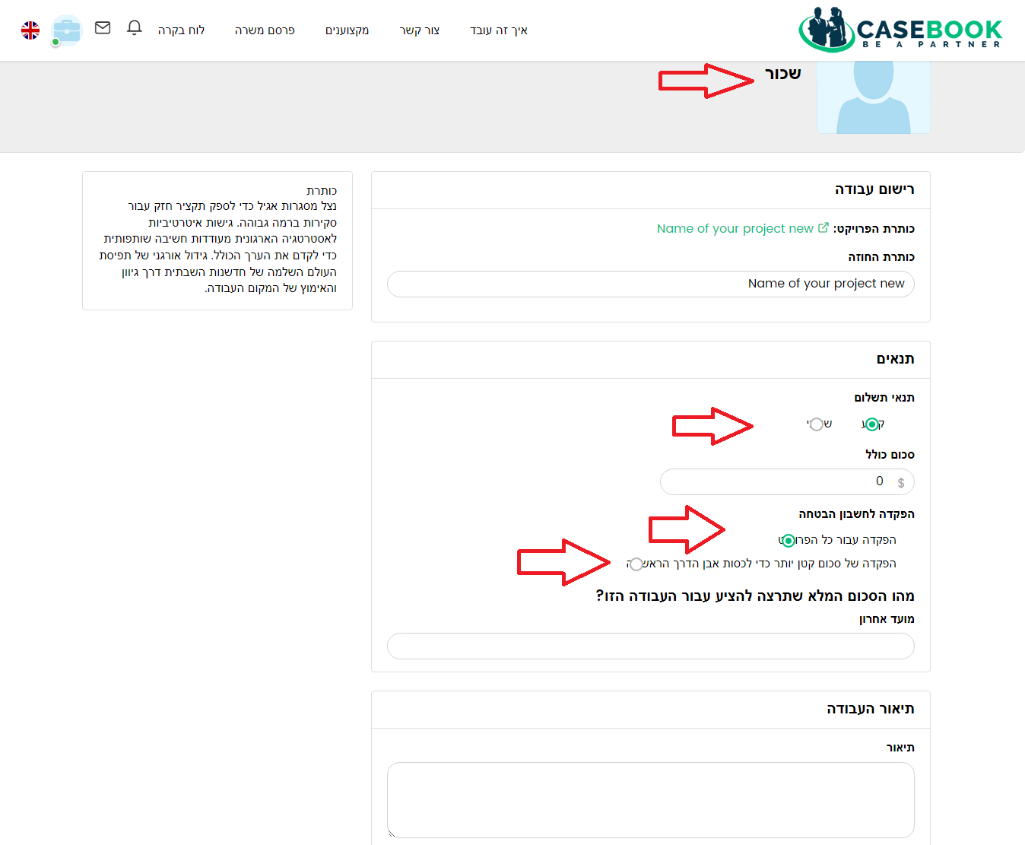
- http://localhost/upwork-casebook/en/contract/details/aab3238922bcc25a6f606eb525ffdc56 (At Hebrew language when click on “Close Project ” Button, then the pop up form become same as English language)
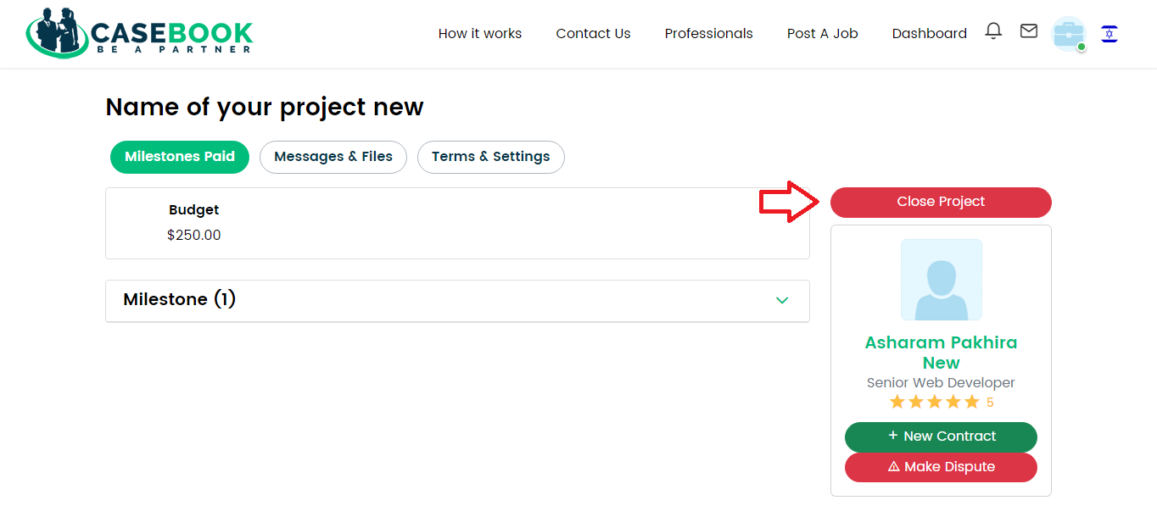
- http://localhost/upwork-casebook/en/projectview/application/7/6 (At Hebrew language name details is not show)

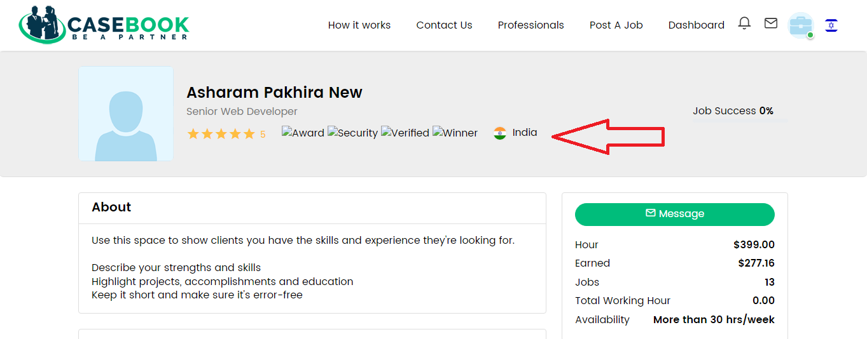

- http://localhost/upwork-casebook/en/projectview/application/7/6 (preview option is not work with both languages)

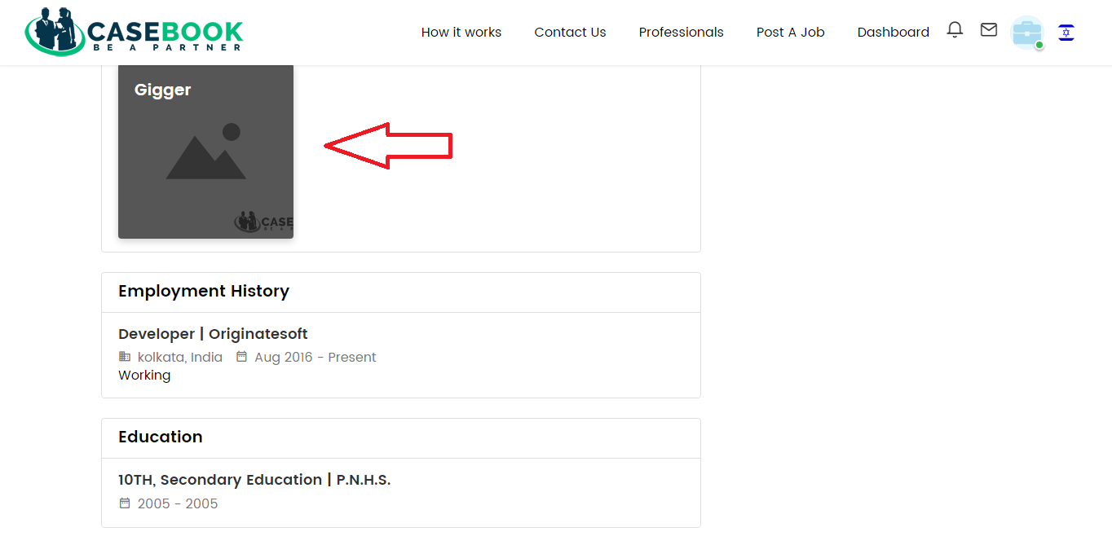

Front Page in Website
- http://localhost/upwork-casebook/en/job/findjobs?order_by=default&category=&sub_category=&is_hourly=&experience_level=&job_type=&min=&max=&term= (At Hebrew language Key skills is not show in each post)

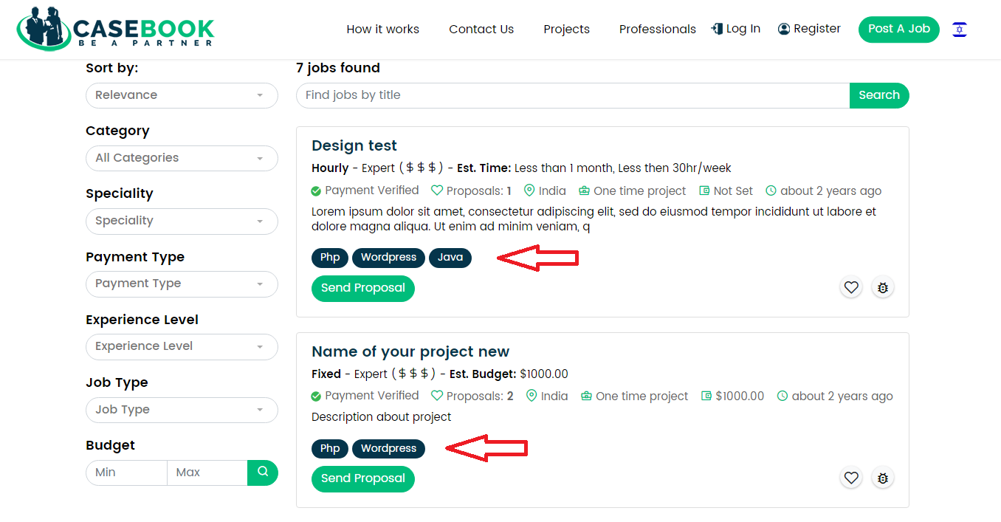

- http://localhost/upwork-casebook/en/job/findjobs?order_by=default&category=&sub_category=&is_hourly=&experience_level=&job_type=&min=&max=&term= (At Hebrew language “Cancel” and “Ok” button position is not changed )
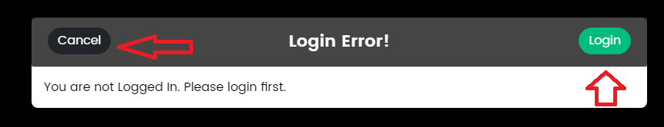

- http://localhost/upwork-casebook/how-it-works (At Hebrew language “How it Works ” page is not properly display)
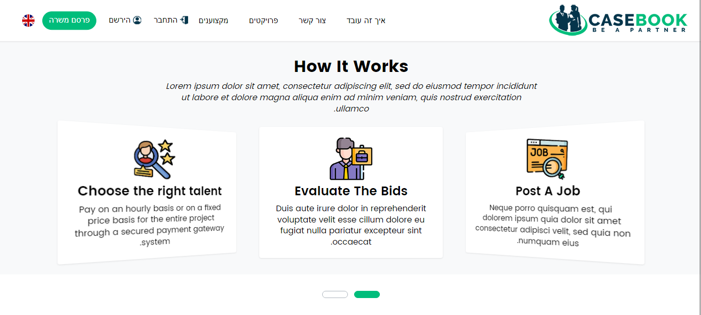
- http://localhost/upwork-casebook/en/help (At Hebrew Language Help section panel is not show)
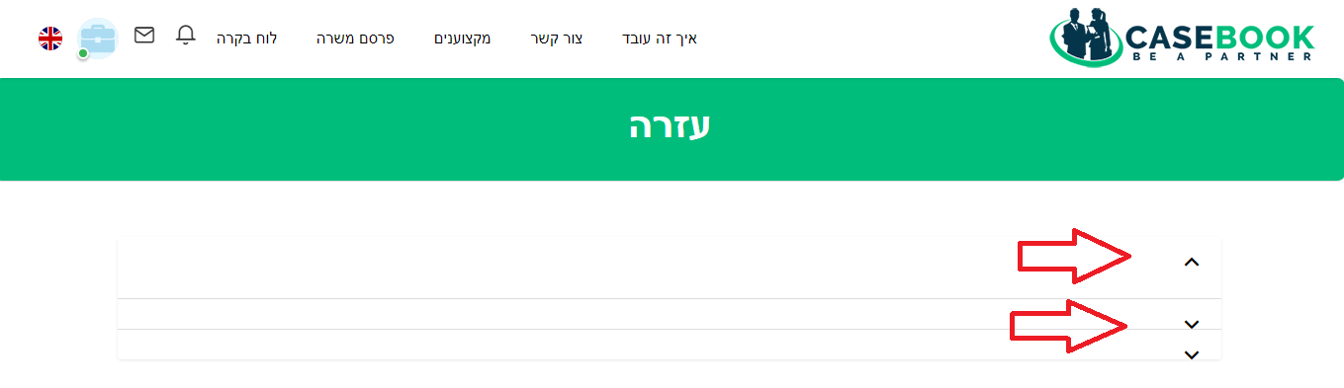
24) http://localhost/upwork-casebook/terms-and-conditions (Hebrew Language “Terms & Condition” title is not show)
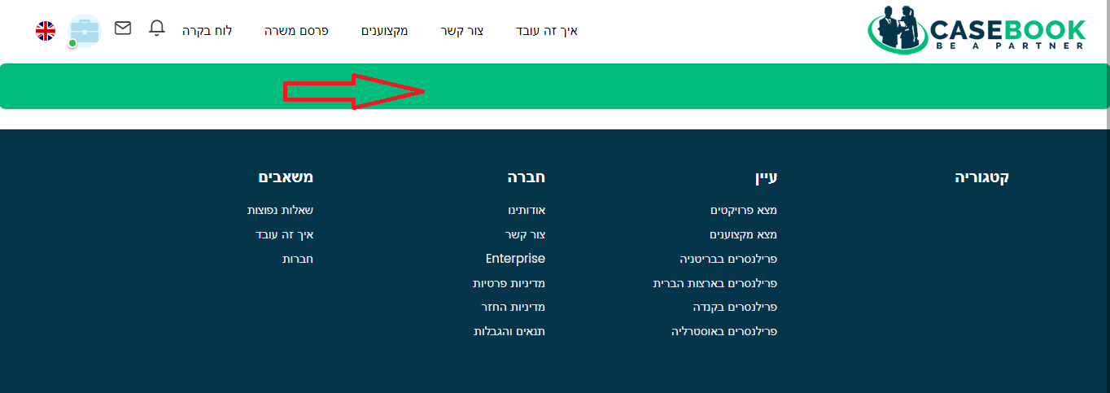
25) http://localhost/upwork-casebook/en/findtalents/all_list?country=AUS&min=&max=&min=&max=&term=&order_by=default (Hebrew Language browse section is not show properly)