**Home Page:**

1. **“What our Client Say section”** is not show at Hebrew Language…

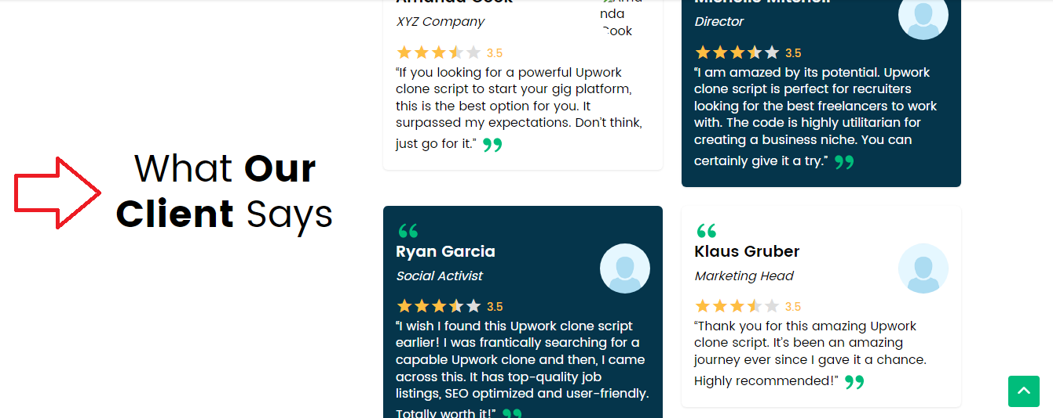

1. All check boxes are not show under “Top Skills” section in Home Page…

