****************************************** * **Up work** ******************************************************

1. [**https://upwrkz.com/postproject/edit/013d407166ec4fa56eb1e1f8cbe183b9/e2df5b1ad8e7a67c874bccd81c0e1af9**](https://upwrkz.com/postproject/edit/013d407166ec4fa56eb1e1f8cbe183b9/e2df5b1ad8e7a67c874bccd81c0e1af9) **(Project Visibility, Experience level, Project time & duration field remain blank.)**

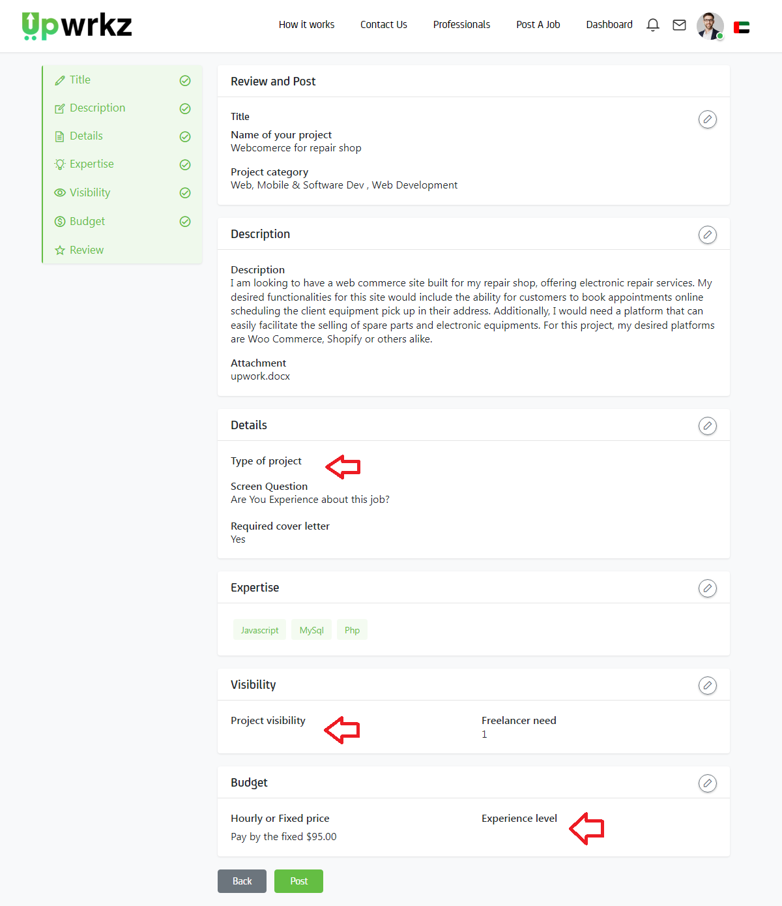

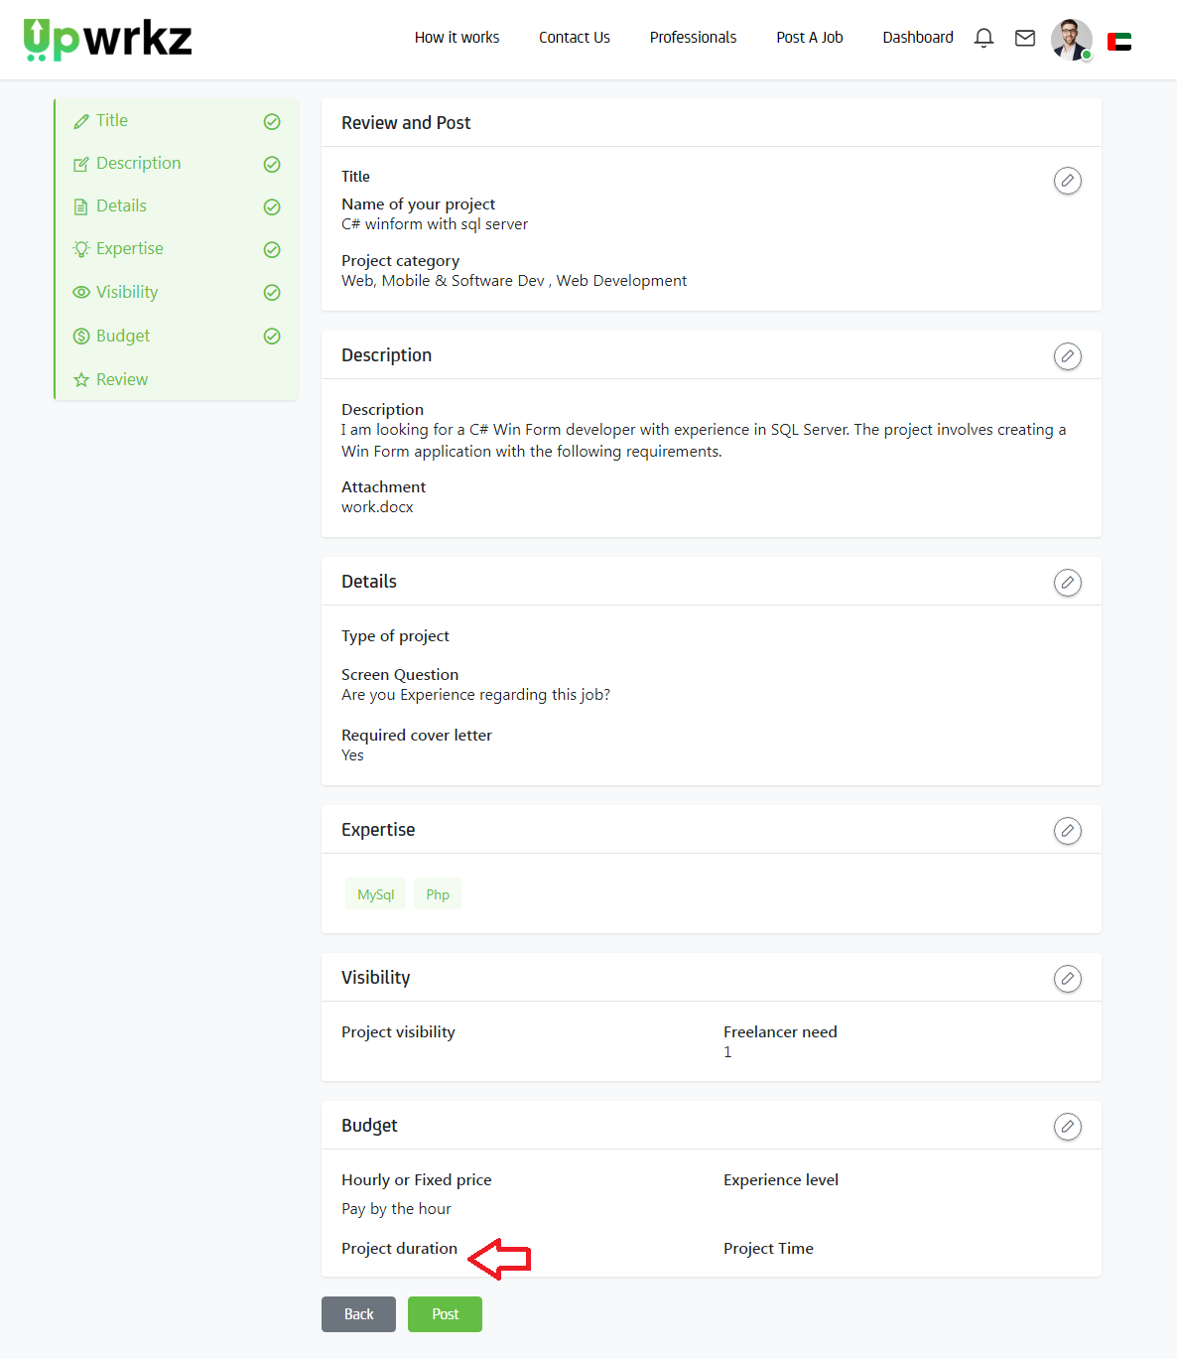

1. <https://upwork.scriptlisting.com/postproject/add> (**Text Should be remove & Box color should be green**)

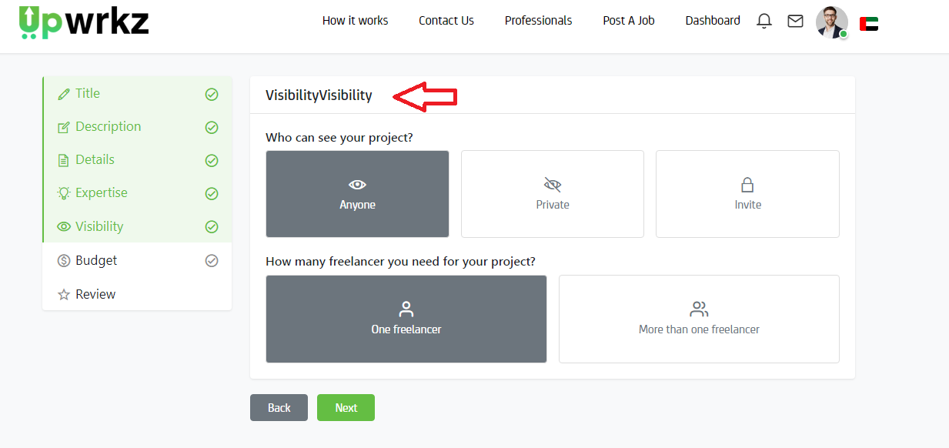

1. <https://upwork.scriptlisting.com/postproject/add> (**Field box color should be green**)

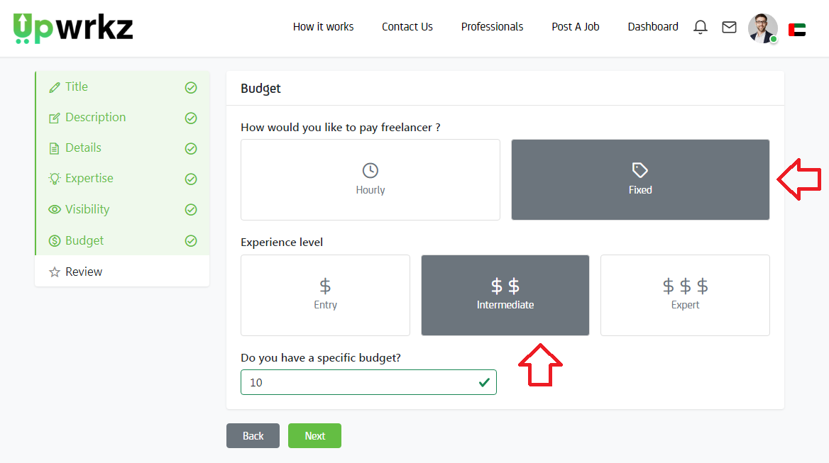

1. <https://upwrkz.com/postproject/edit/013d407166ec4fa56eb1e1f8cbe183b9/e2df5b1ad8e7a67c874bccd81c0e1af9> (At the time of edit project box color have not in the field)

