****************************************** * **Up work** ******************************************************

1. **Project Visibility, Experience level, Project time & duration field remain blank.**

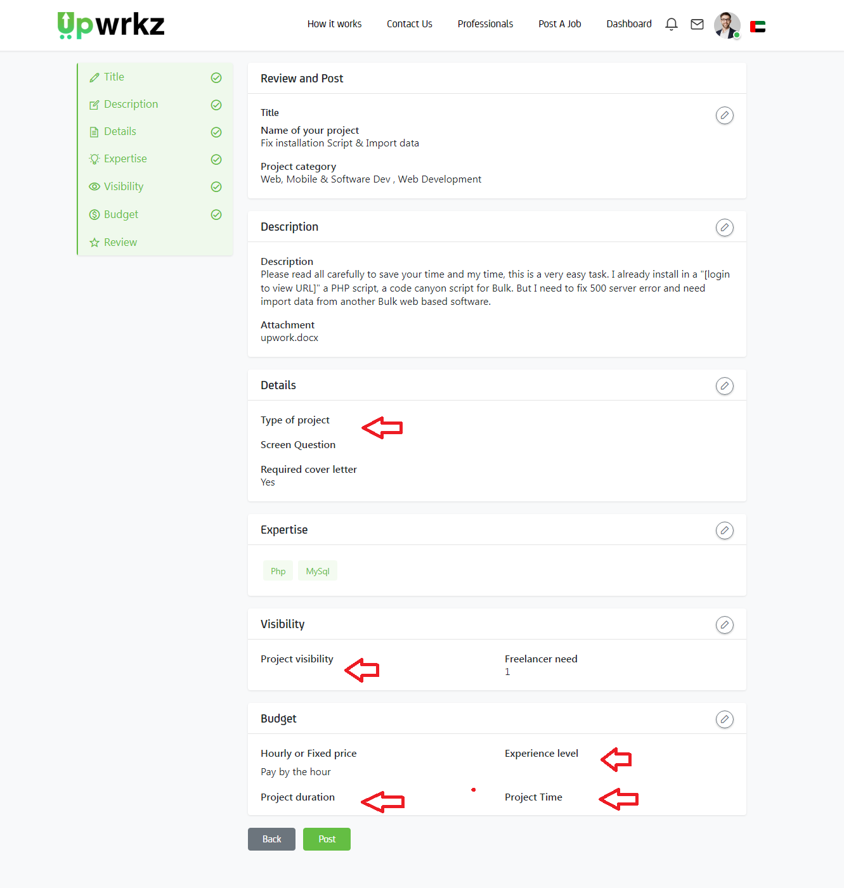

1. <https://upwork.scriptlisting.com/postproject/add> (**Text Should be remove & Box color should be green**)

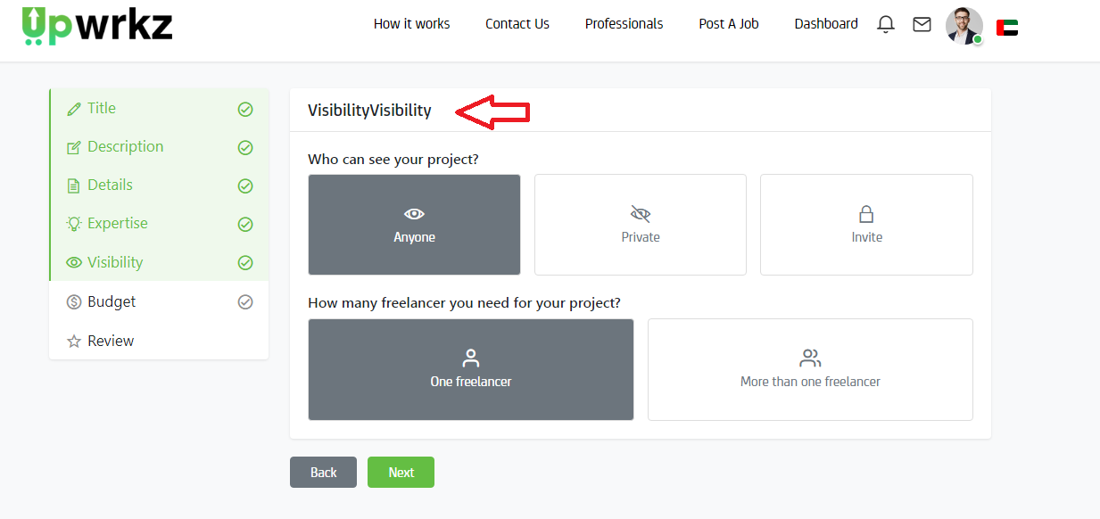

1. <https://upwork.scriptlisting.com/postproject/add> (**Field box color should be green**)

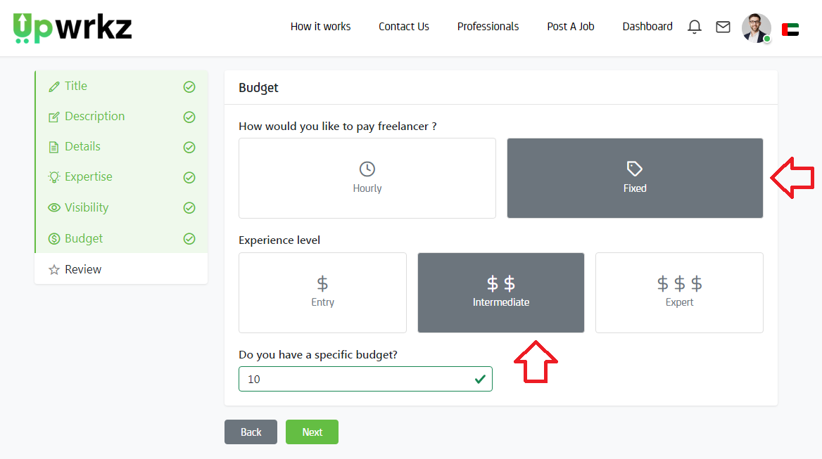

4)