********************************************* **Up Work** **************************************************

1. <https://upwork.scriptlisting.com/ar/> (**At Hebrew Language banner image is not show Properly like as English language**)

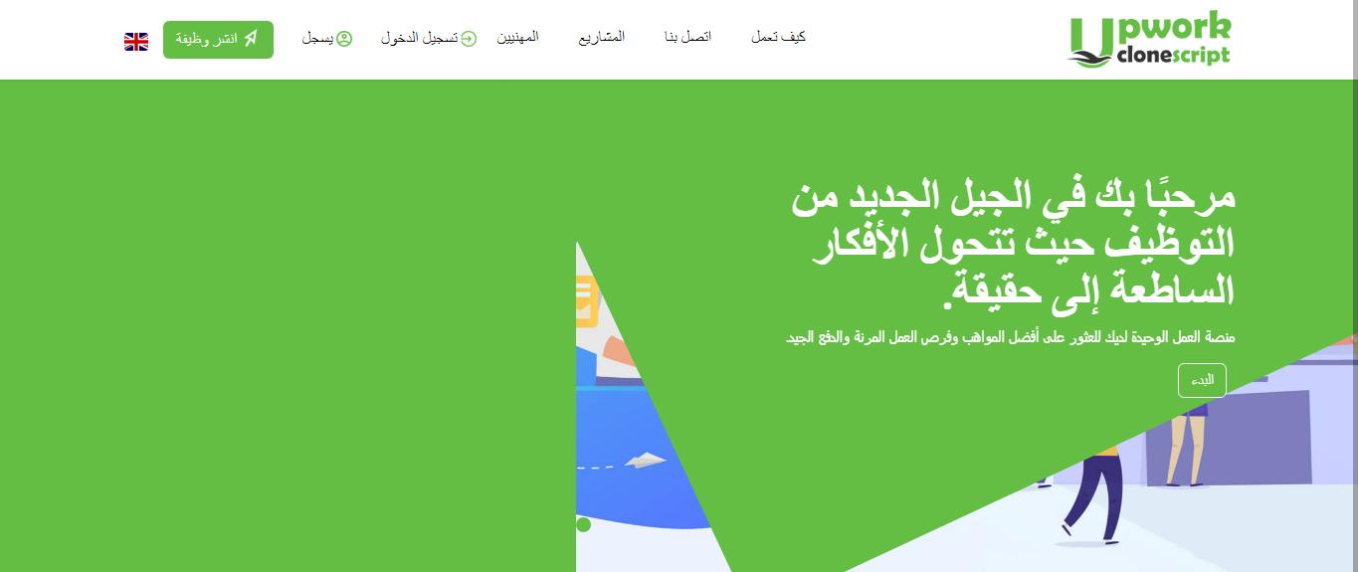

1. <https://upwork.scriptlisting.com/> (**At Hebrew Language Slider image is not come**)

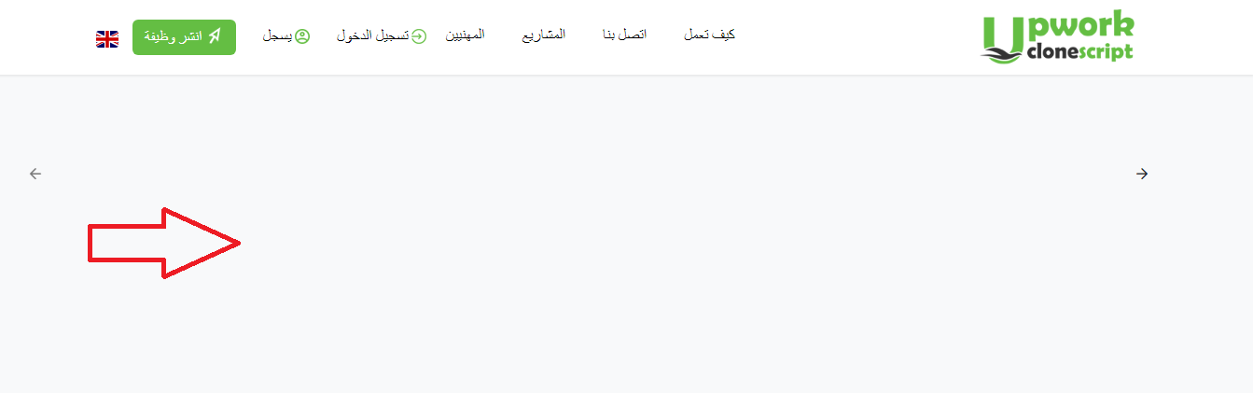

1. <https://upwork.scriptlisting.com/ar/> (**At Hebrew Language** **text is not come below the image)**

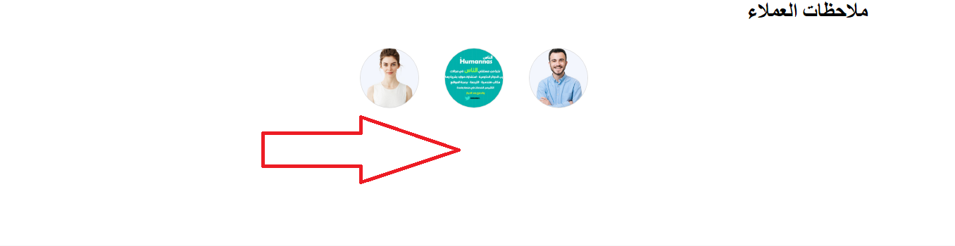

**Freelancer Section**

1. <https://upwork.scriptlisting.com/ar/contract/offer/d09bf41544a3365a46c9077ebb5e35c3> (**Button alignment is not same**)

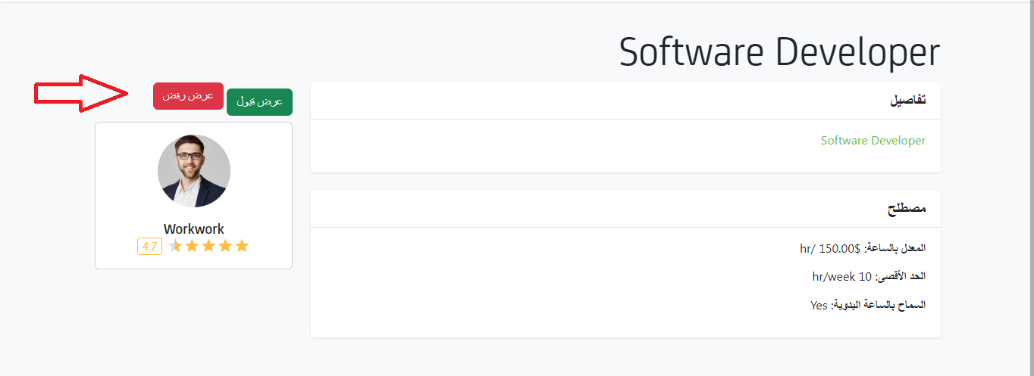

1. <https://upwork.scriptlisting.com/ar/contract/term/7647966b7343c29048673252e490f736> **(Button position is not Right way)**

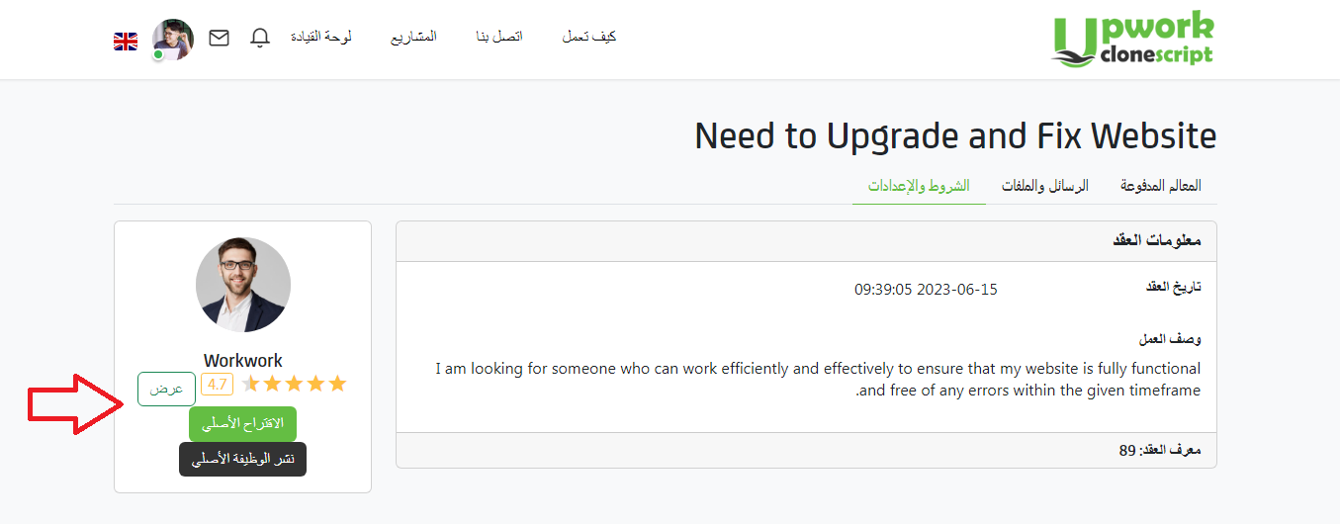

1. <https://upwork.scriptlisting.com/ar/workroom/worklog/c7e1249ffc03eb9ded908c236bd1996d?show=completed> (**At Hebrew language button is not exact position**)

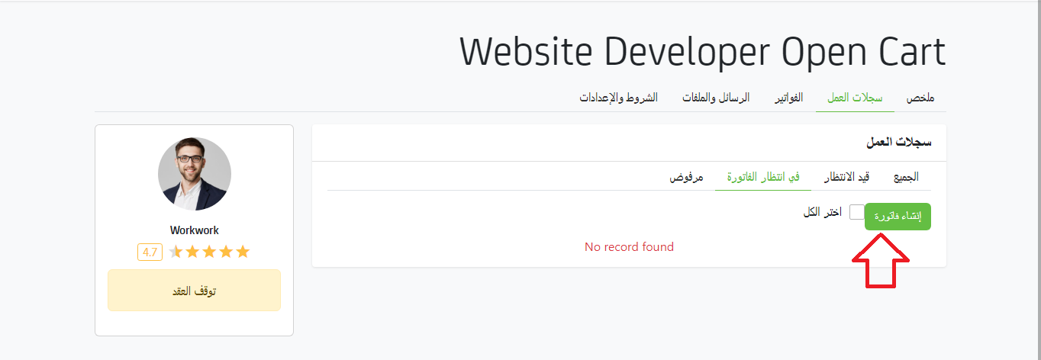

1. <https://upwork.scriptlisting.com/ar/invoice/details/9f61408e3afb633e50cdf1b20de6f466> (**At Hebrew language invoice details alignment is same as default language**)

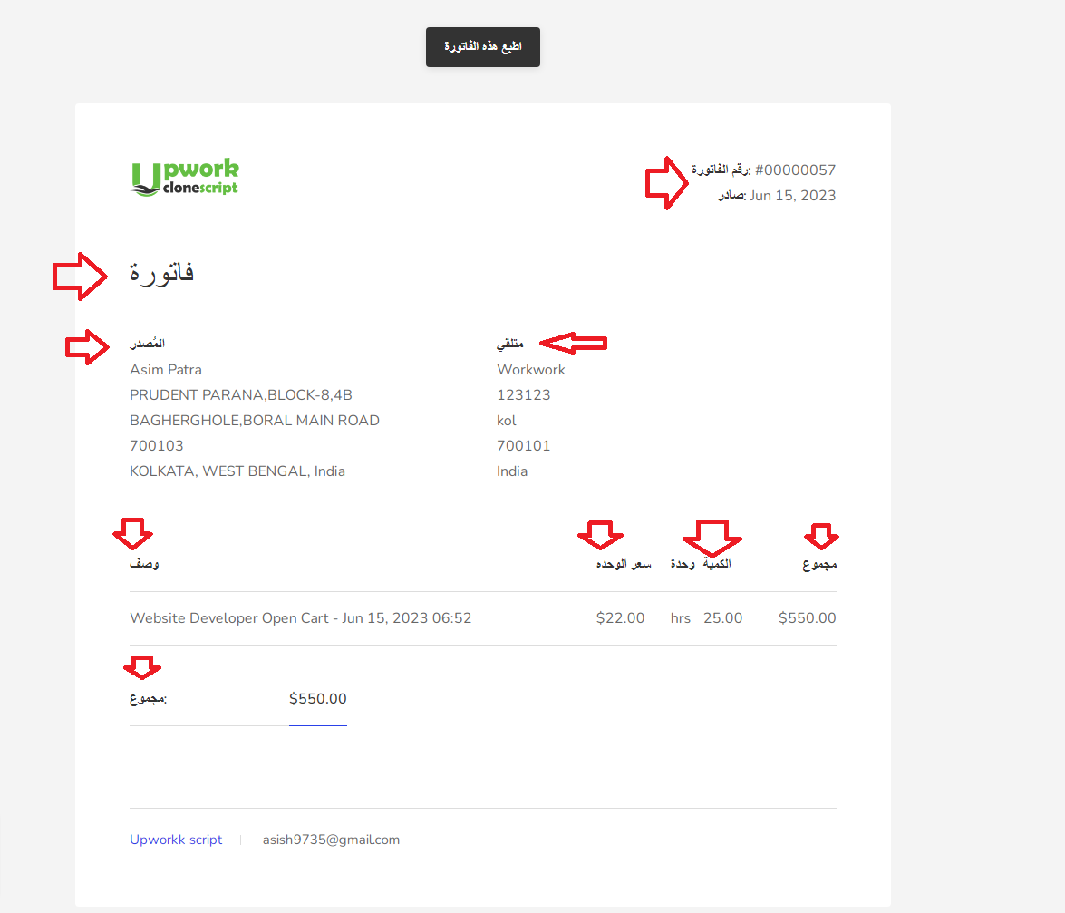

1. <https://upwork.scriptlisting.com/ar/favorite> (**At Hebrew language Position is same as default language**)

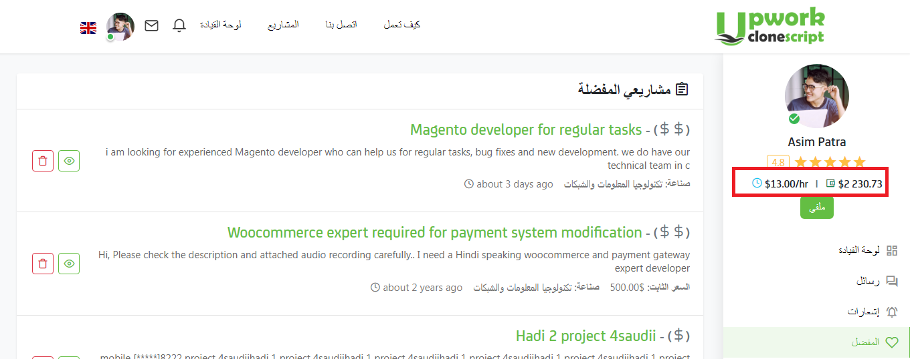

1. <https://upwork.scriptlisting.com/ar/profileview/view/16> (**At Hebrew language Text have adjacent with delete icon it should gap between them**)

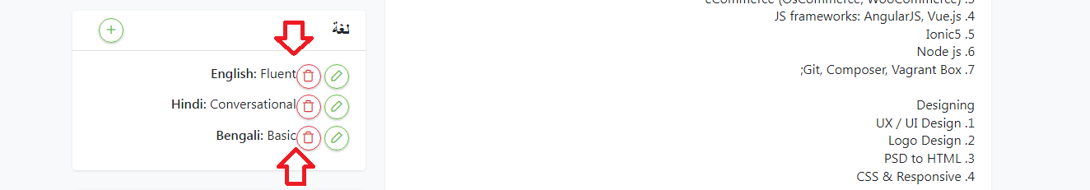

1. <https://upwork.scriptlisting.com/ar/profileview/view/16> (**At Hebrew language Radio button is not placed proper place)**

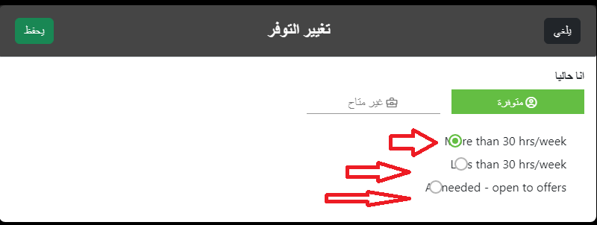

1. <https://upwork.scriptlisting.com/ar/profileview/view/16> (**At Hebrew language Text alignment should be right side**)

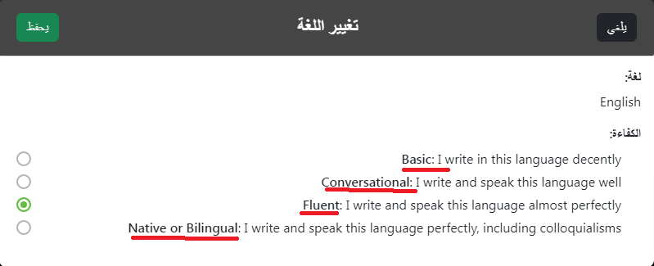

1. <https://upwork.scriptlisting.com/ar/apply-job/food-blog-website-management> (**At Hebrew language Radio button is not placed properly**)

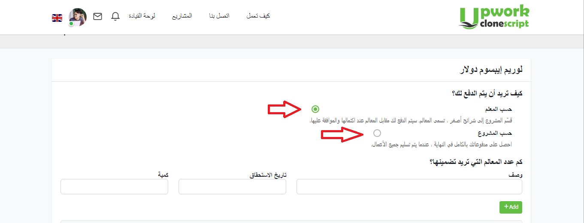

1. <https://upwork.scriptlisting.com/ar/finance/withdraw> (**At Hebrew language button have very close to text)**

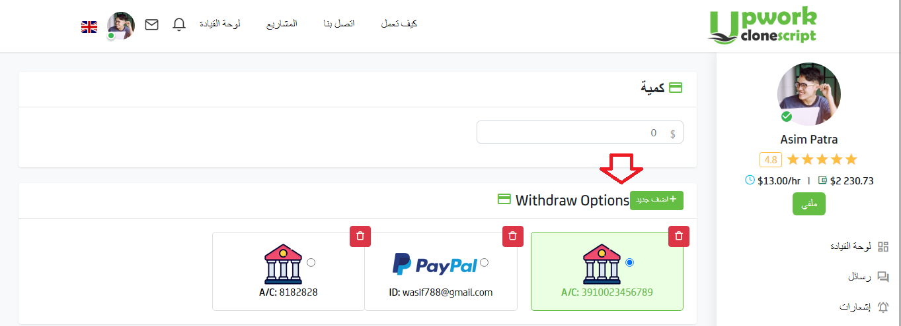

1. <https://upwork.scriptlisting.com/ar/p/need-to-upgrade-and-fix-website> (**At Hebrew language two circle button very close to each other)**

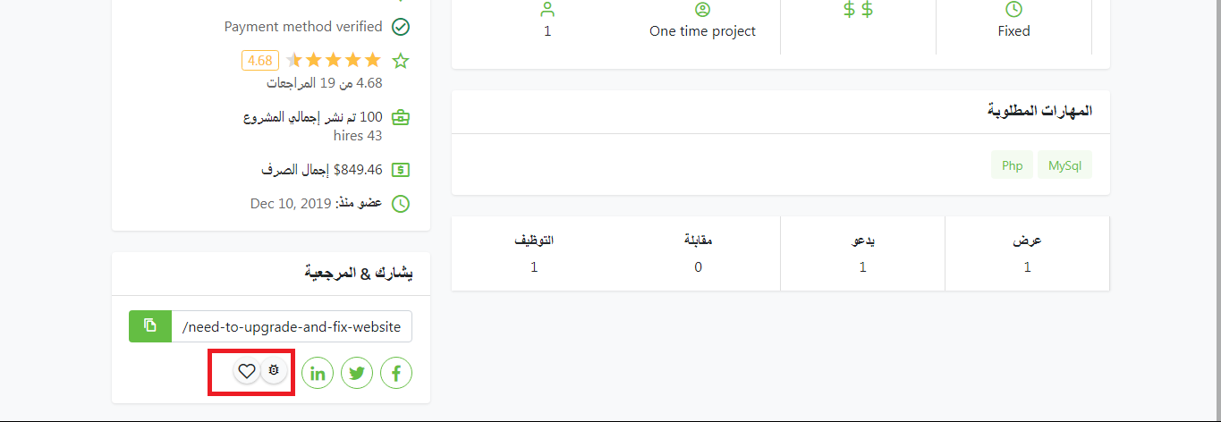

1. <https://upwork.scriptlisting.com/ar/contract/details/7647966b7343c29048673252e490f736> (**At Hebrew language button is very close to text)**

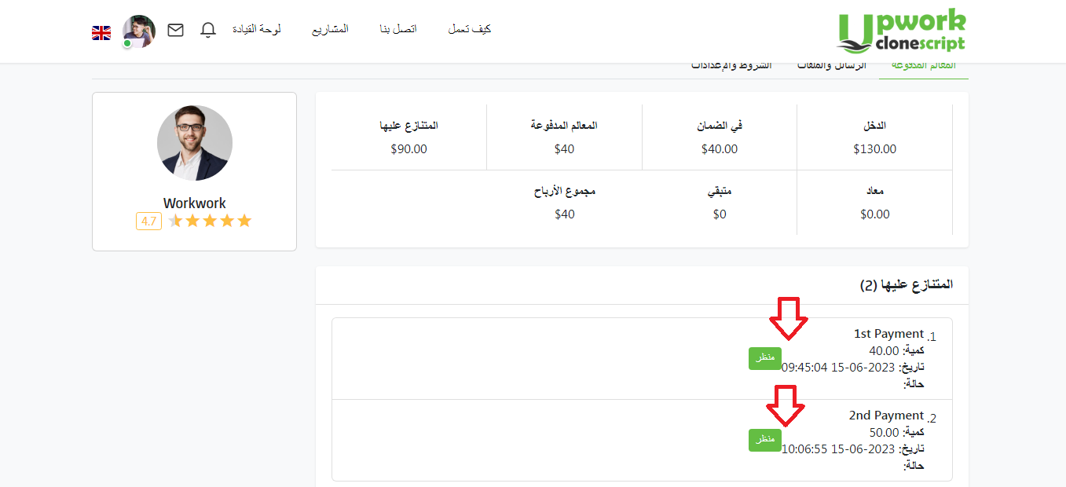

1. <https://upwork.scriptlisting.com/ar/password/security_password> (**At Hebrew language edit icon is very close to text**)

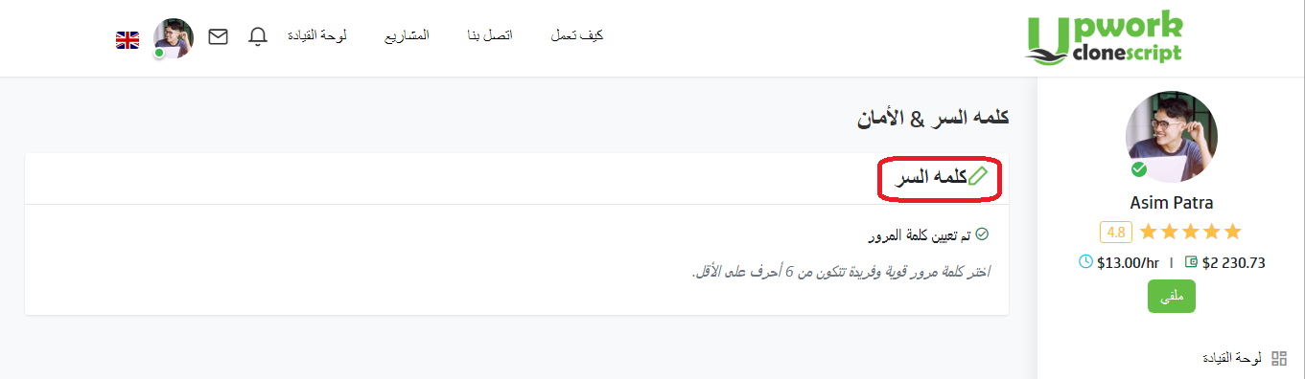

**Employer Section**

1. [**https://upwork.scriptlisting.com/contract/details/7647966b7343c29048673252e490f736**](https://upwork.scriptlisting.com/contract/details/7647966b7343c29048673252e490f736) **(At Hebrew language button alignment is different than default language and also button is very close to text)**

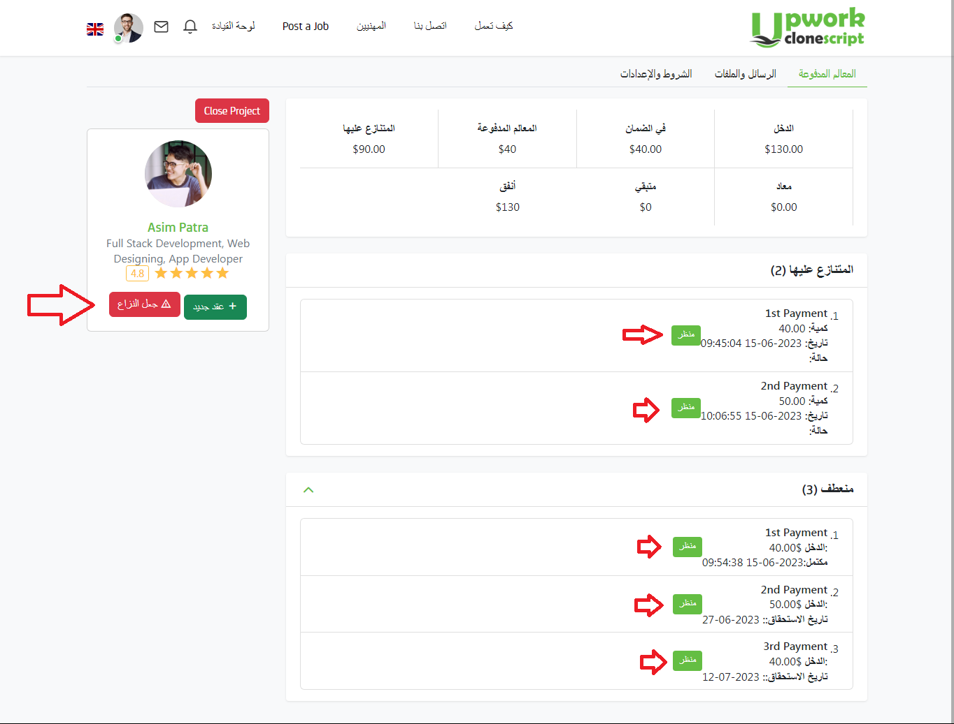

1. [**https://upwork.scriptlisting.com/ar/message**](https://upwork.scriptlisting.com/ar/message) **(At Hebrew language icon & text is very close to each other)**

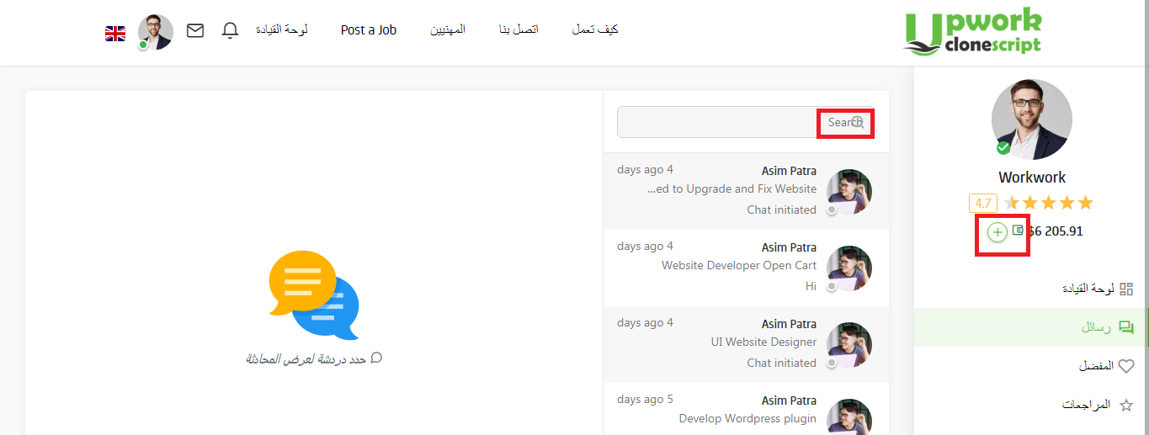

1. [**https://upwork.scriptlisting.com/ar/projectview/hire/c45147dee729311ef5b5c3003946c48f/c4ca4238a0b923820dcc509a6f75849b**](https://upwork.scriptlisting.com/ar/projectview/hire/c45147dee729311ef5b5c3003946c48f/c4ca4238a0b923820dcc509a6f75849b) **(At Hebrew language Radio button is not properly placed)**

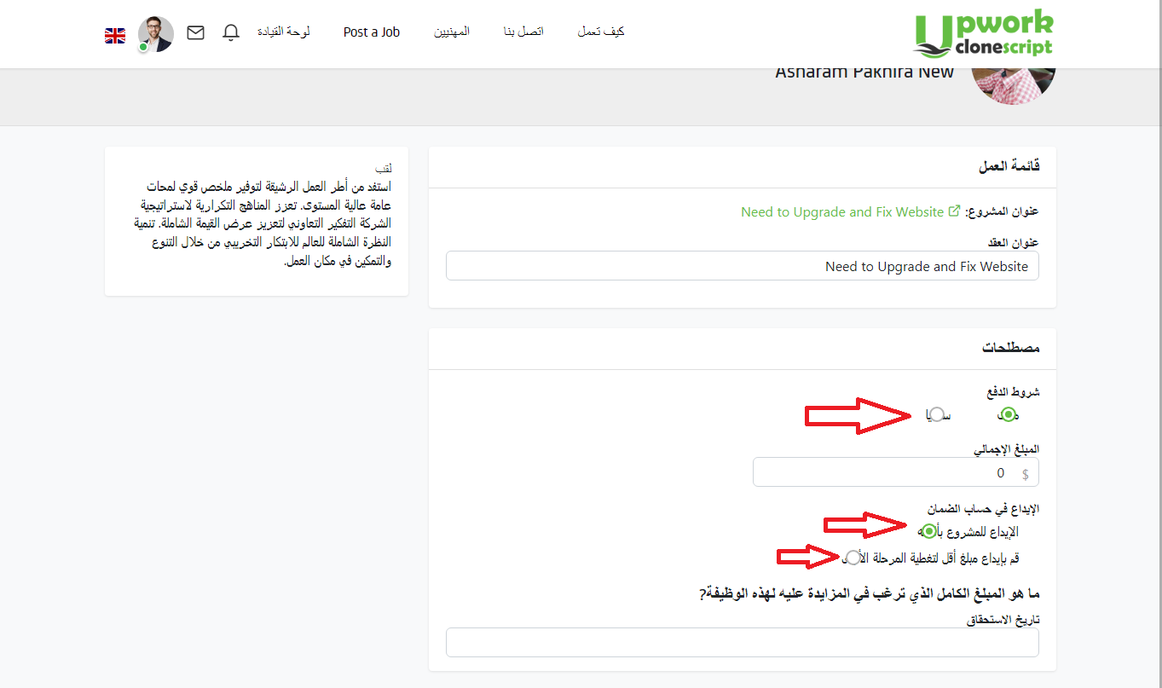

**Front Section**

1. [**https://upwork.scriptlisting.com/ar/job/findjobs?term=&order_by=default&category=&sub_category=&is_hourly=&experience_level=&job_type=&min=&max**](https://upwork.scriptlisting.com/ar/job/findjobs?term=&order_by=default&category=&sub_category=&is_hourly=&experience_level=&job_type=&min=&max)**= (At Hebrew language text keep space between two button)**

