****************************************** * **Up work** ******************************************************

**Date: 14-06-23**

1. **Project Visibility & Experience level field remain blank**

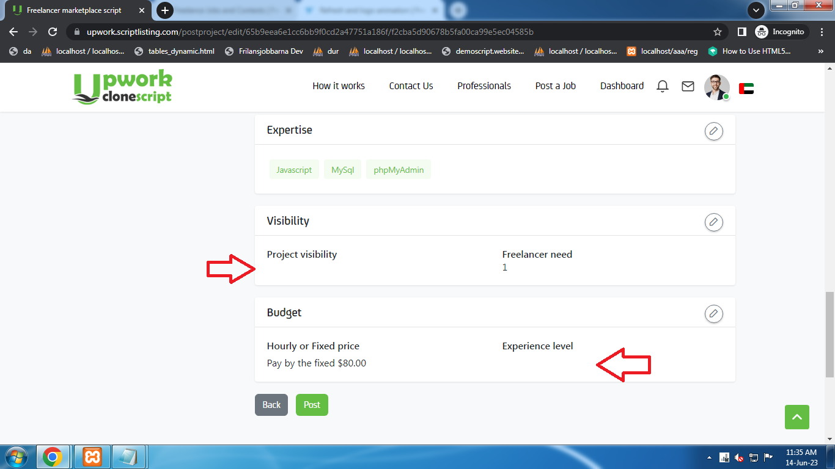

2) **Data should be added in Sub Category fields…**

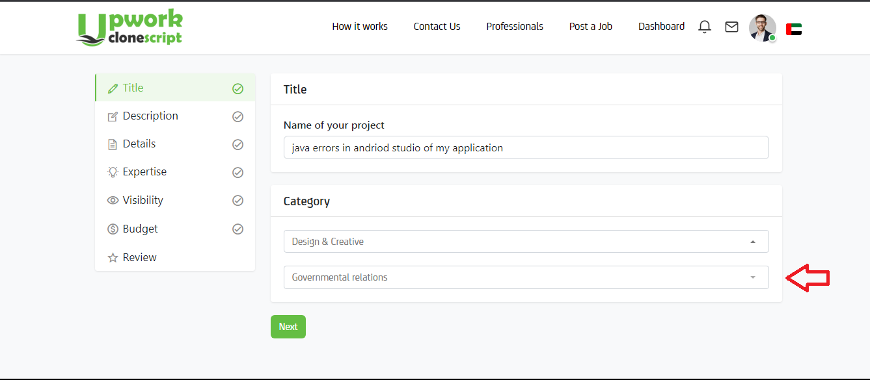

1. **Key Skill should more add in the field.**

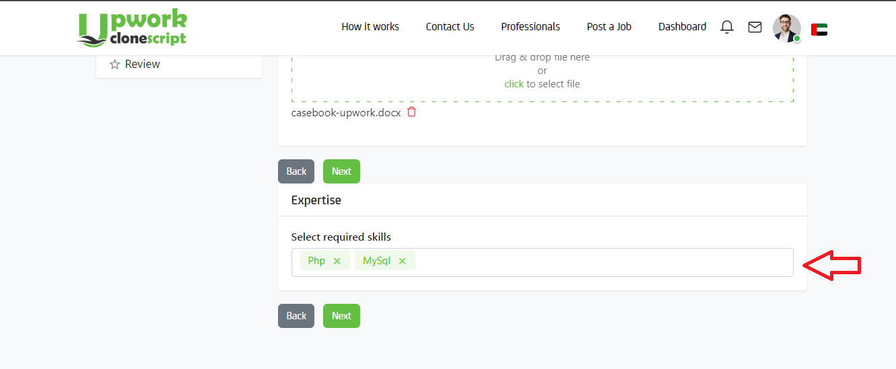

1. **Field Keep blank after fill the field**

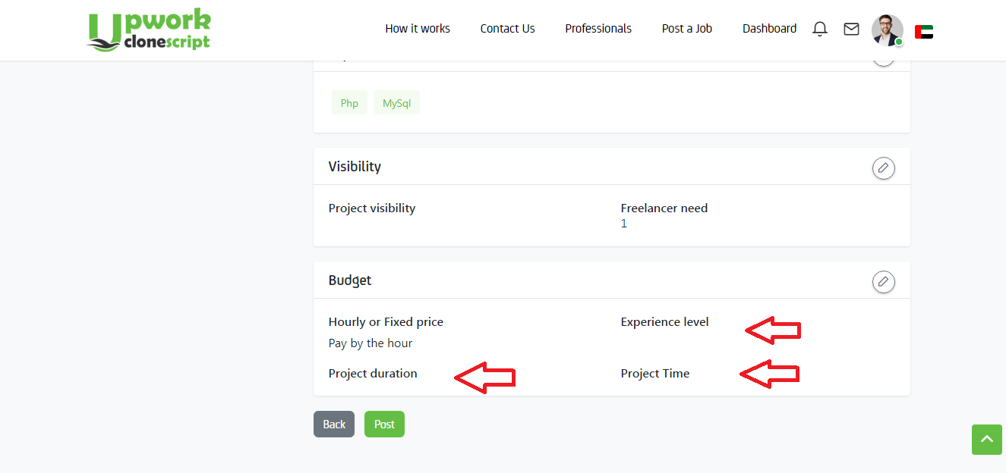

1. https://upwork.scriptlisting.com/workroom/worklog/68d30a9594728bc39aa24be94b319d21?show=rejected

(Date is not defined in calendar section)

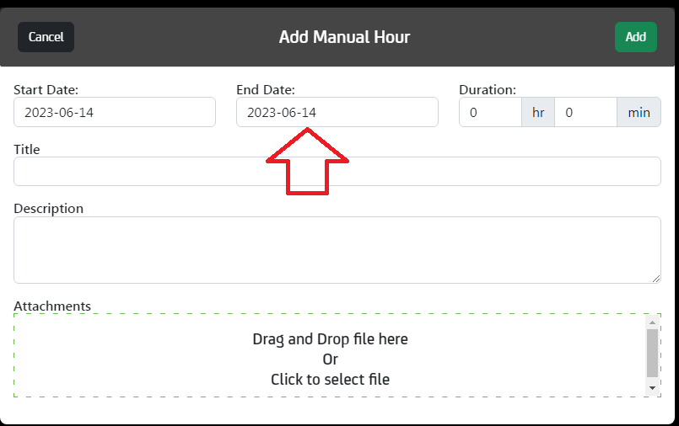

1. <https://upwork.scriptlisting.com/postproject/add> (Text Should be remove)

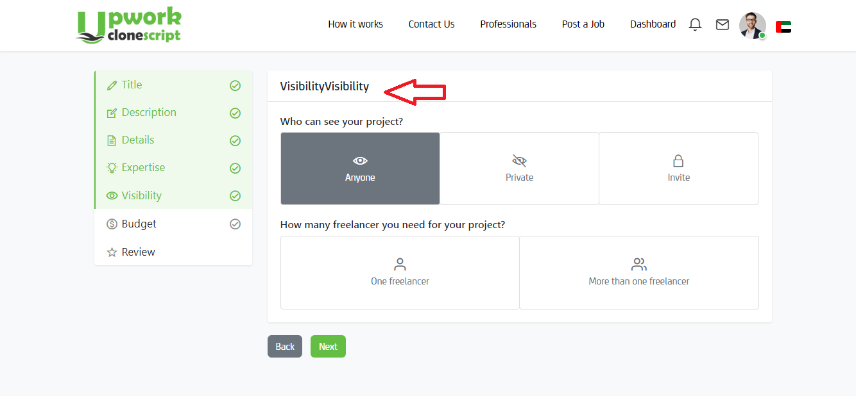

**Freelancer Section**

1. [**https://upwork.scriptlisting.com/ar/projectview/application/116/76**](https://upwork.scriptlisting.com/ar/projectview/application/116/76) **( Edit option is not work)**

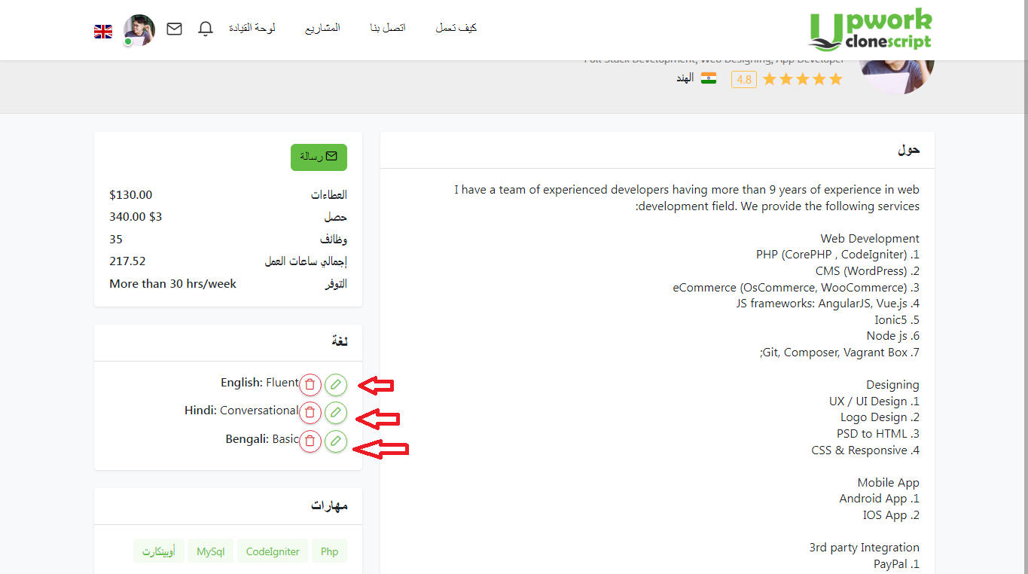

2)